**Software Documentation for the Transport Management System**

**Product Name: Transport System**

Release Version:

Testing Started:

Testing Completed:

Technical Lead:

Product Owner: BBA

Primary Tester:

Developer:

Types of Test Performed:

**Browser Tested:**

1. Chrome

2. Mozilla Firefox

**Device Tested:**

1. Desktop

2. Laptop

3. Tab

4. Smartphone

**Instance Tested:**

1. Development

2. Testing

3. Production

4. UAT

**Table of Contents**

Revision History 4

Design Specification 5

Abstract 6

Chapter-1: Introduction 7

1.1 Review of the current Transport System 7

1.2 Motivation 7

1.3 Aims and Objective 7

1.4 Solution Methodology 8

Chapter - 2. Background Study 9

2.1 Transport Management System 9

2.2 Why should we use this software system ? 9

2.3 User Experience 9

2.4 Requisition Control 9

2.4.1 Requisition Information 9

2.4.2 Servicing Information 9

2.4.3 Fuel Information 9

2.4.4 Benefits 10

2.4.5 Report & Analysis 10

2.5 TMS main modules 10

Chapter – 3: Software Requirement Analysis 12

3.1 Introduction 12

3.2 Requirement 12

3.3 Software Requirement Specifications 12

3.3.1 SRS Scopes 12

3.3.2 Functional Requirements 12

3.3.3 Non-functional Requirement 12

3.4 Interface Requirement 13

3.4.1 User Interface 13

3.4.2 Hardware Interface 14

3.4.3 Software interface 14

3.4.4 Communication Interface 14

3.5 SRS table 14

3.6 Report Analysis 15

Chapter – 4: System Design 17

4.1 Algorithm Design 17

4.2 Process Flow Diagram 17

4.3 Data Flow Diagram 18

Chapter – 5: Testing Documentation 20

5.1 Introduction 20

5.2 Scopes 20

5.3 Quality Objective 20

5.4 Testing Methodology 21

5.4.1 Model 21

5.4.2 Strategies 21

5.4.3 Levels 21

5.4.4 Test Deliverables 21

5.4.5 Tools 22

5.5 Test Cases with Result 22

# Revision History

|  |  |  |  |
| --- | --- | --- | --- |
| Date | Version | Description | Author |
|  |  |  |  |
|  |  |  |  |
|  |  |  |  |
|  |  |  |  |

# Design Specification

**Overview:**

Transport Management System is the vital part of Management Control System which provides overall management process of Transport. This system contains several functionality which can access specific parts of the system for security purposes and also has two section like server, client side as well as back-end and front-end part that manage all the functionality of the software system.

**The Back-end part:**

1. Node.js

2. Database → Oracle

3. MS Server Version 2.0

**The Front-end part:**

1. React.js

2. Bootstrap

3. Domain → Friendly

# Abstract

Transport Management System clarifies the designation of a system that introducing to the management of necessary steps to determine the proper utilization of vehicle or transport. For vehicle requisition query, the system should be updated. In each requisition term, the overall status should be generated and also be reported in a document. As the transport system connects a multiple section, so it should be controlled by a standard software system. According to the software requirement specifications, there have to be designed a software system that can perform all of the tasks and can cover the area of the transport system.

# Chapter-1: Introduction

In this chapter, we are going to discuss about the Current Transport System, our motivation from the current system, our goals and how can find an optimal solution to achieve our objectives that are described in the section no 1.1, 1.2, 1.3, 1.4 respectively.

Transport Management System includes Load Planning, Vehicle Scheduling, Route optimization and Driver Management for easily manages all Transport Needs.

## 1.1 Review of the current Transport System

The Transport Management System is developed in such a way that user can access every functionality easily. The old transport system is also less Secure and user has to give much effort because this old transport system does not generate each and every records. It is more difficult to find old records in the old transport system.

## 1.2 Motivation

Our new system makes transport maintenance easy and requires less man power and less time for maintaining the records of the transportation firm. In our new system everything is computerized and transport management is totally transparent.

## 1.3 Aims and Objective

Our aims is to achieve a good transport system that has ability to fulfill our requirements.

* Platform Independent
* Auto Synchronizing
* Friendly Environment
* Domain and Hosting
* Requisition Control
* Requisition History
* Vehicle Management
* Vehicle Management History
* Generate Each section Report
* Multi-functionality

## 1.4 Solution Methodology

In this Section, we discuss about the preplan terms to get proper solution. We are analyzing the requirements and select a design model to design the plan. In this software system, waterfall model is selected that gives a optimal result, reducing cost and performs in efficient way. Implementation and operation is done by some software and hardware tools.

# Chapter - 2. Background Study

## 2.1 Transport Management System

The Transport Management System is the application developed to manage the transportation work easily keeping the transport up to date regarding the vehicles information. They have to keep track of each and every vehicles they have in their transport Requisition. They have to record each and every transport trip of the vehicles to manage the vehicles information.

## 2.2 Why should we use this software system ?

For better user experience, managing all the things related to the transport system, we can use this software system. Instead of manual process of transport system, we use this software system that helps to make everything easier. All the transportation information will be stored in customized manner.

## 2.3 User Experience

Transport Software System is used by the user’s to operate the transport system. An user can easily handle the software. Less complexity in the system can make user experience more better.

## 2.4 Requisition Control

This section explains how to add requisition and generate report, approval of them by admin panel. This controlling procedure is operate by User for requisition, Super Admin for retrieving a requisition, system admin for approval, transport admin for selecting requisition.

### 2.4.1 Requisition Information

Requisition status are explained in this section to visualize about Requisition information. In the requirement list we can see the status whether the requisition pending or approved.

### 2.4.2 Servicing Information

Vehicle servicing section gives the information about vehicle repairing and there servicing center information. Servicing information store all the record like parts and product, workshop’s name.

### 2.4.3 Fuel Information

Store Fuel type information regarding to the vehicles.

### 2.4.4 Benefits

* Save time - Manually it takes a lot of time while storing the lease information
* Resources - except this software system, the gathering of lease information will be

difficult as there need a lot of man power resources in rural and urban areas.

* Reusable - the system can be reused in the similar types of management.
* Decision making in future - one can make a decision in future whether the system is

more better than other.

* vehicles performance – the generated report can give performance about respective vehicle.

### 2.4.5 Report & Analysis

TMS extends the requisition from the user and transport admin. And generate Requisition list and status. In every sub-modules, there is a option to download the current report instantly.

## 2.5 TMS main modules

* Login Process
* Requisition Dashboard
* Add new requisition
* Requisition List
* Vehicle Information

1. Vehicle List
2. Types
3. Models
4. Manufactures
5. Pools

* Requisition Information

1. Requisition List
2. Pending
3. Approved

* Servicing Information

1. Parts Category
2. Parts & Products
3. Workshop
4. Servicing List

* Fuel & Mobil Information

1. Fuel Type
2. Fuel List

# Chapter – 3: Software Requirement Analysis

## 3.1 Introduction

A software requirement is a field within software engineering that deals with establishing

the needs of stakeholders that are to be solved by software. The IEEE Standard Glossary of

Software Engineering Terminology defines requirements.

## 3.2 Requirement

The Transport Management System Requirements provides high-level of functional requirements.

## 3.3 Software Requirement Specifications

* Documentation (user and administration)
* Operational behavior
* Requisition Status
* Vehicle Status
* Technical Support

### 3.3.1 SRS Scopes

In according the lease act, the following information should be provided and stored.

1. Unique Login Id
2. Requisition information
3. Summary dashboard
4. Vehicle Information, Servicing Information, Fuel Information

### 3.3.2 Functional Requirements

Every section has a specific functionality that’s are given below:

* Login – user, admin, super admin, transport admin
* Dashboard – automatically generated.
* User’s Role - add Requisition.
* Report – download a copy of corresponding section.

### 3.3.3 Non-functional Requirement

For an specific criteria, there should be applied non-functional requirements which are

shortly described below:

**Reliability**

The operational interface can’t fail within a period of time.

**Availability**

The system is available or not while a user wants access the information.

**Security**

All user can login to the system with secured procedure. Each user has a unique

identification system. Admin can store user’s login information.

**Maintainability**

All source code and related document should be controlled under a version of the

system.

**Portability**

As the software run into several platform, the platform independence should be ensure.

Different OS can access the software easily.

**Usability**

The Software should be easy to use and given a positive experience by the

user’s.

## 3.4 Interface Requirement

Computer system including software and hardware can turn the system on by interfacing

them with human thought.

### 3.4.1 User Interface

* Login Screen
* Home Screen
* Dashboard
* New Requisition
* Requisition list
* Vehicle information

### 3.4.2 Hardware Interface

* Server Configuration
* CPU/Processor
* Windows with apache preloaded
* Client Configuration

### 3.4.3 Software interface

* OS = Windows, Linux
* Language = PHP, JS
* DB = Oracle

### 3.4.4 Communication Interface

These interfaces include E-mail, Web Browser, Server Network and use http or ftp for

security purposes.

## 3.5 SRS table

It describes necessary behavior of the software system and shows in the table

3.1.

|  |  |  |
| --- | --- | --- |
| S.No. | Requirement Name | Requirement Classified |
| 1. | Login |  |
| 2. | New Requisition |  |
| 3. | Requisition List |  |
| 4. | Vehicle Information |  |
| 5. | Requisition Information |  |
| 6. | Vehicle |  |
| 7. | Servicing |  |
| 8. | Fuel & Mobil |  |

## 3.6 Report Analysis

Independent to each other. At the end of the phase, the document of the requirement will be provided.

**Priority Checklist**

* Level-1**:** Must Be Performed
* Level-2: Must be perform for next level
* Level -3: Not Mandatory

|  |  |  |  |
| --- | --- | --- | --- |
| S.No. | Requirement Name | Functional/Non-  functional | Priority |
| 1. | Login | Functional | 1 |
| 2. | Dashboard | Functional | 2 |
| 3. | Report | Functional | 3 |
| 4. | New Requisition | Functional | 1 |
| 5. | Requisition List | Functional | 2 |
| 6. | **Vehicle** | Functional | 2 |
| 7. | Vehicle Record | Functional | 1 |
| 8. | Vehicle Types | Functional | 1 |
| 9. | Models | Functional | 1 |
| 10. | Manufactures | Functional | 1 |
| 11. | Pools | Functional | 1 |
| 12. | **Requisition Information** | Functional | 2 |
| 13. | Record | Functional | 2 |
| 14. | Pending | Functional | 2 |
| 15. | Approved | Functional | 2 |
| 16. | **Servicing** | Functional | 2 |
| 17. | Parts Category | Functional | 1 |
| 18. | Parts & Product | Functional | 1 |
| 19. | Workshop | Functional | 1 |
| 20. | Servicing Record | Functional | 2 |
| 21. | **Fuel & Mobil** | Functional | 2 |
| 22. | Fuel Type | Functional | 1 |
| 23. | Fuel Record | Functional | 1 |
| 24. | Reliability | Non-functional | 1 |
| 25. | Availability | Non-functional | 1 |
| 26. | Security | Non-functional | 1 |
| 27. | Maintainability | Non-functional | 1 |
| 28. | Portability | Non-functional | 1 |
| 29. | Usability | Non-functional | 1 |
| 30. | Database | Functional | 1 |

# Chapter – 4: System Design

## 4.1 Algorithm Design

|  |  |
| --- | --- |
| STEP – 1: START  STEP – 2: CHECK Authentication  STEP – 3: CALL Fun(X)  STEP – 4: if(X = ‘requisitioner’)  ADD newRequsition  SHOW requisitionList  if(X = ‘superadmin’)  SHOW requsitionList  SELECT requisition  SEND requisition  if(X = ‘admin’)  SHOW requisitionNotification  DO approve OR deny | if(X = ‘transportadmin’)  SHOW requisitionList  SELECT settings  ADD vehicleInfo,  servicingInfo,  FuelInfo  STEP - 5: SHOW dashboard  STEP – 6: END |

## 4.2 Process Flow Diagram

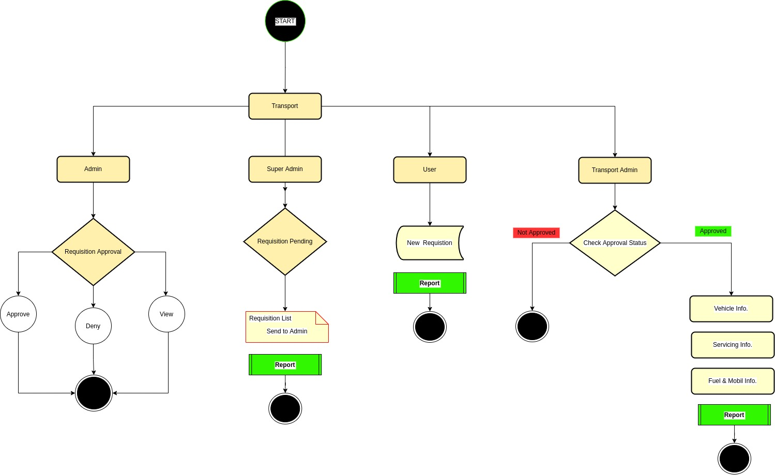

## 4.3 Data Flow Diagram

## 

# Chapter – 5: Testing Documentation

## 5.1 Introduction

The Test Plan is designed to prescribe the scope, approach, resources, and schedule of all testing activities of the transport Management System of BBA. The plan identify the items to be tested, the features to be tested, the types of testing to be performed, the personnel responsible for testing, the resources and schedule required to complete testing, and the risks associated with the plan.

## 5.2 Scopes

**1. In scope:**

|  |  |  |
| --- | --- | --- |
| Name | Applicable Roles | Description |
| New Requisition | User, Transport Admin | Add a new requisition for approval |
| Requisition List | User, Super admin, Transport Admin | Show the requisition status |
| Vehicle Information | Transport Admin | Manage Vehicle records |
| Requisition Information | Super Admin | Check and send Requisition for Approval |
| Servicing Information | Transport Admin | Manage Servicing Recording |
| Fuel & Mobil Information | Transport Admin | Record Fuel type |

**2. Out scope**

* User Interface (UI)
* Hardware
* System security and performance

## 5.3 Quality Objective

The test objectives are to verify the Functionality of the system Lease Management System, the project should focus on testing the transportation system such as vehicle requisition, vehicle information, add new vehicle information to guarantee all these operation can work normally in real business environment.

## 5.4 Testing Methodology

### 5.4.1 Model

* **Waterfall model** – a dynamic approach where each step depends on the previous one, where the developers follow some sequence of steps progressively downwards forwards to achieve the goal. It is like a waterfall approach containing several phases.

### 5.4.2 Strategies

• Tester has access to the full view of code.

• It is known as transparent or glass box testing

• Avoiding errors and wasting time at an early stage

• White box testing contains various tests -

1. Basic Path testing
2. Loop testing
3. Condition testing
4. Memory perspective testing
5. Performance testing

### 5.4.3 Levels

* Integration testing
* System testing
* Cross Browser Compatibility testing

User Acceptance Test (UAT)

* API testing

### 5.4.4 Test Deliverables

(a) Before Testing

* Test plans document
* Test case document

(b) After Testing

* Test Results/reports
* Defect Report
* Installation/ Test procedures guidelines

### 5.4.5 Tools

|  |  |  |
| --- | --- | --- |
| No. | Resources | Description |
| 1. | Server | Oracle Database Server |
| 2. | Network | LAN line. |
| 3. | Computer | PC and other OS configuration |

## **5.5 Test Cases with Result**

**Test Scenario 1: Login Functionality Check**

For All User:

*Positive test case*

|  |  |  |  |  |  |
| --- | --- | --- | --- | --- | --- |
| Case ID | Title | Description | Expected Result | Actual Result | Pass/Fail |
| 1 | Login | 1. Visit login page  2. Enter username  3. Enter password  4. Click login  5. Change password (if forgot)  6. Keep login | Data saved successfully | Go to the login page | P |

*Negative Test Case*

|  |  |  |  |  |  |
| --- | --- | --- | --- | --- | --- |
| Case ID | Title | Description | Expected Result | Actual Result | Pass/Fail |
| 1 | Login |  | Data checked | Login page | P |

For Requisitioner & Transport Admin:

**Test Scenario 2: Dashboard**

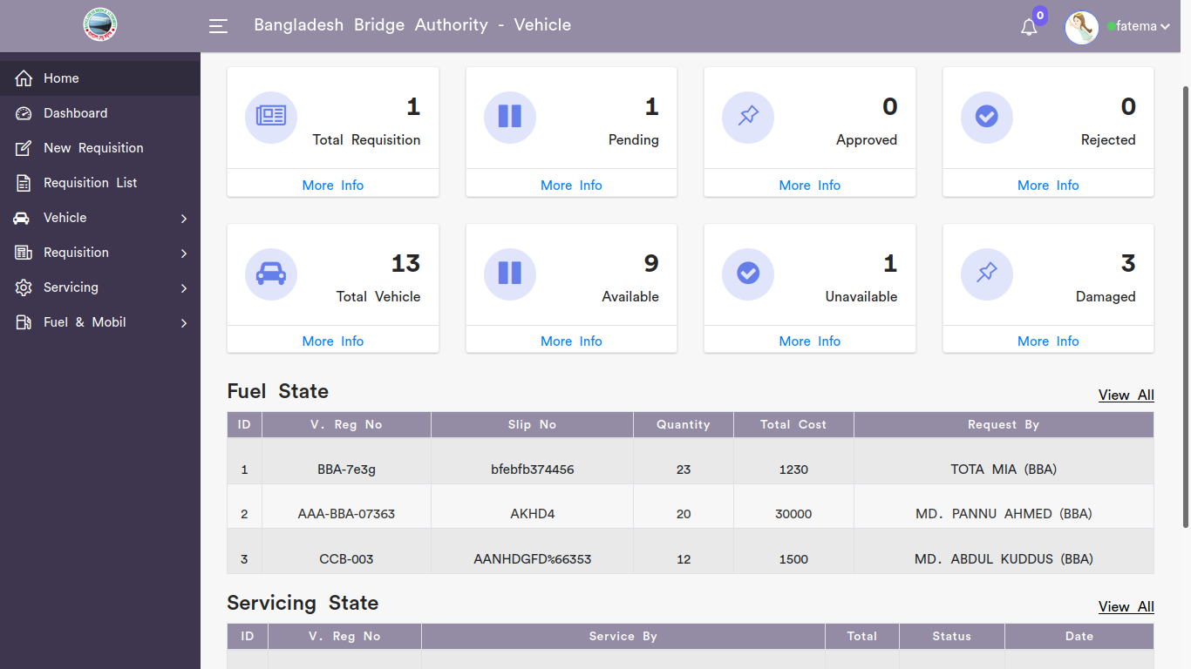



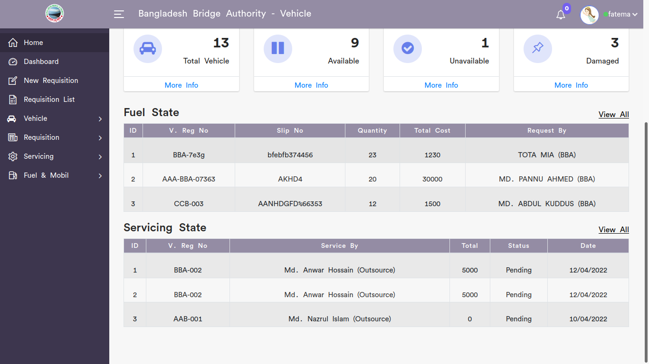

*Positive test case*

|  |  |  |  |  |  |
| --- | --- | --- | --- | --- | --- |
| Case ID | Title | Description | Expected Result | Actual Result | Pass/Fail |
| 1 | Total Requisition | 1. Click total requisition to see all requisition information  2. Click pending to see all pending requisition  3. Click approved to see all approved requisition  4. Click rejected to see all rejected requisition | Displayed all information successfully | Perfectly works | P |
| 2 | Total Vehicle | 1. Click total vehicle to see all vehicle information  2. Click available to see all available vehicles  3. Click unavailable to see all unavailable vehicles  4. Click damaged to see all damaged vehicles   |  |  |  | | --- | --- | --- | |  | Perfectly works | P | | Displayed all information successfully | Perfectly works | P |
| 3 | Fuel State | Click view all to see Fuel state information | Displayed all information successfully | Perfectly works | P |
| 4 | Servicing State | Click view all to see servicing state information | Displayed all information successfully | Perfectly works | P |

*Negative Test Case*

|  |  |  |  |  |  |
| --- | --- | --- | --- | --- | --- |
| Case ID | Title | Description | Expected Result | Actual Result | Pass/Fail |
| 1 | Total Requisition | Display information without missing | Successfully operated | No error | P |
| 2 | Total Vehicle | Display information without missing | Successfully operated | No error | P |
| 3 | Fuel State | Display information without missing | Successfully operated | No error | P |
| 4 | Servicing State | Display information without missing | Successfully operated | No error | P |

**Test Scenario 3: New Requisition**

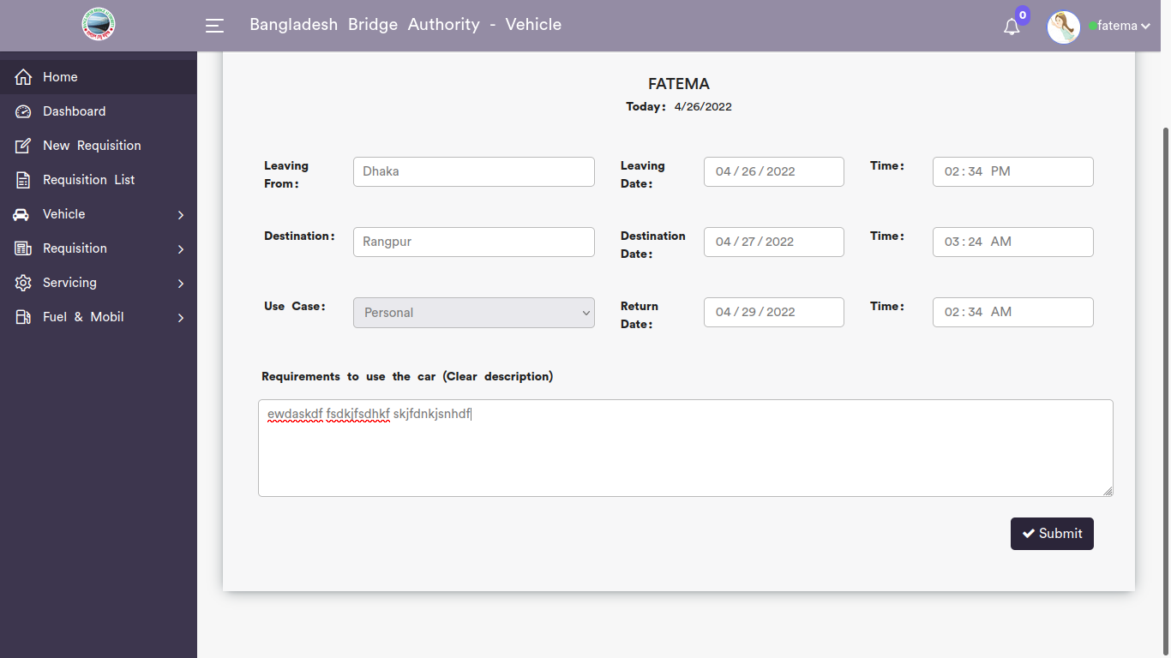

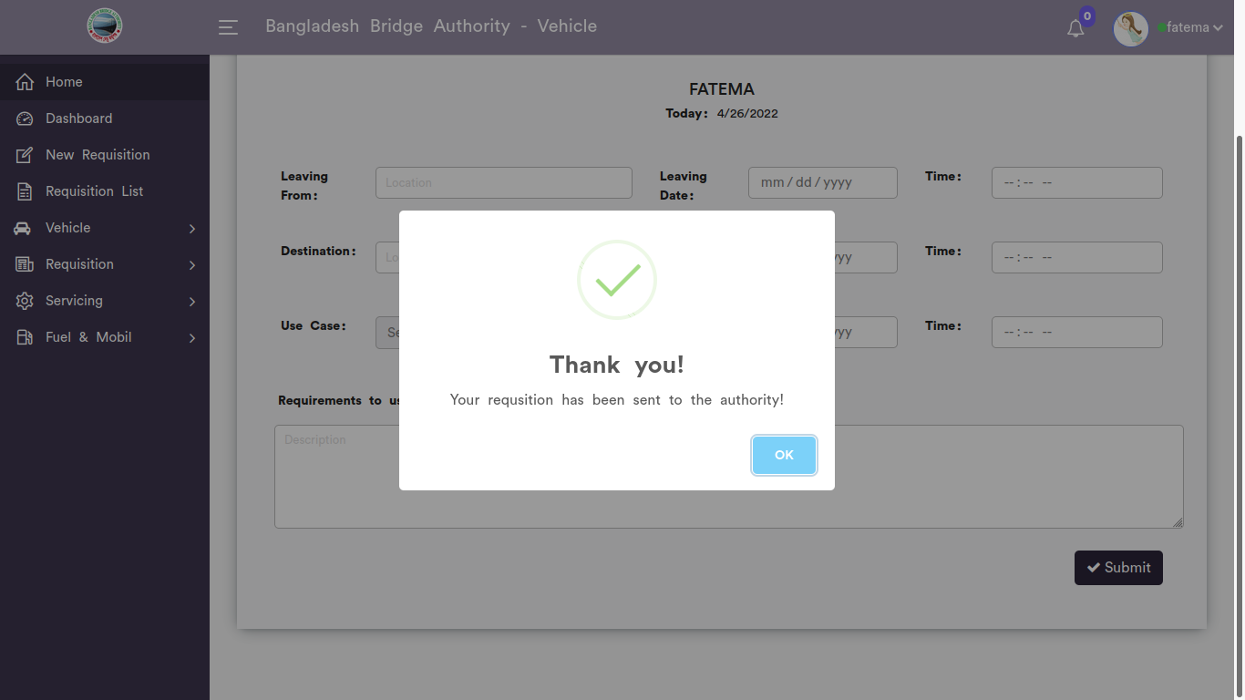

*Positive test case*

|  |  |  |  |  |  |
| --- | --- | --- | --- | --- | --- |
| Case ID | Title | Description | Expected Result | Actual Result | Pass/Fail |
| 1 | Vehicle Requisition Form | 1. Enter Leaving location  2. enter date and time  3. enter destination location  4. Enter date and time  5. Enter requirements for using transportation  5. click submit | Data saved successfully | No error while saving | P |

*Negative Test Case*

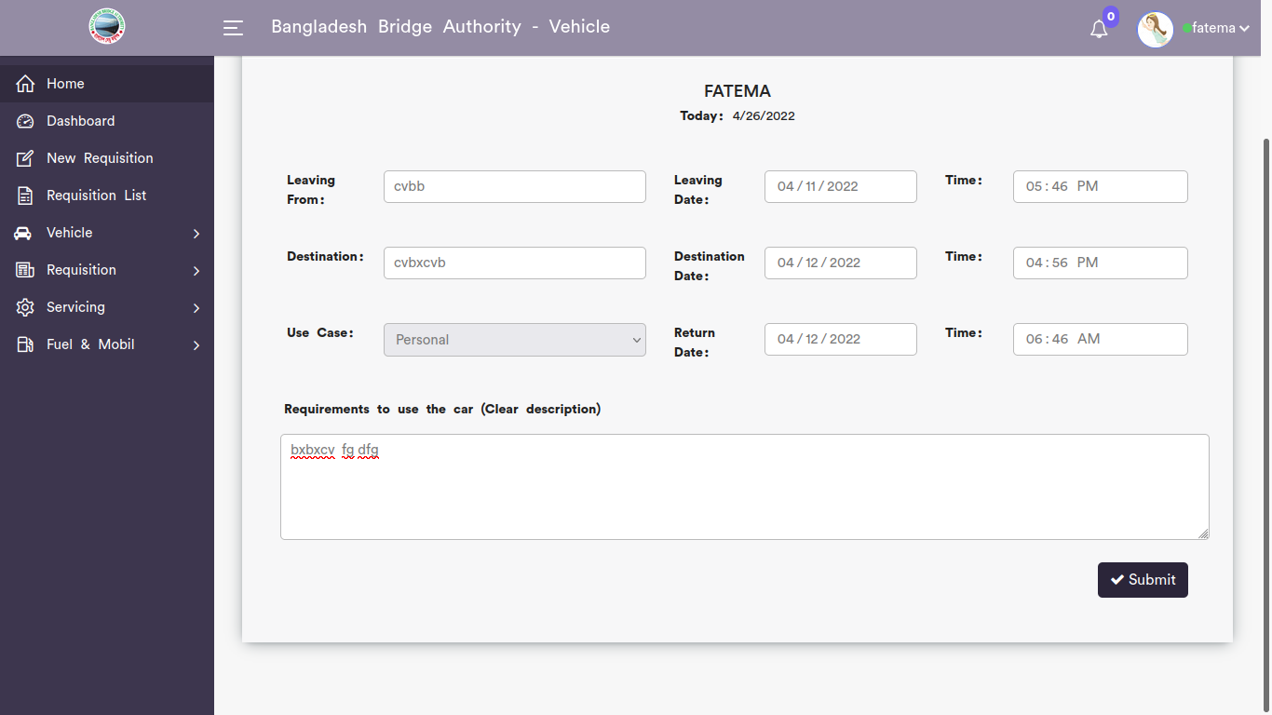

|  |  |  |  |  |  |
| --- | --- | --- | --- | --- | --- |
| Case ID | Title | Description | Expected Result | Actual Result | Pass/Fail |
| 1 | Vehicle Requisition Form | 1. Enter location & date should be valid  2. Submit button should work fine | Stored successfully | All are ok | P |

**Test Scenario 4: Requisition List**

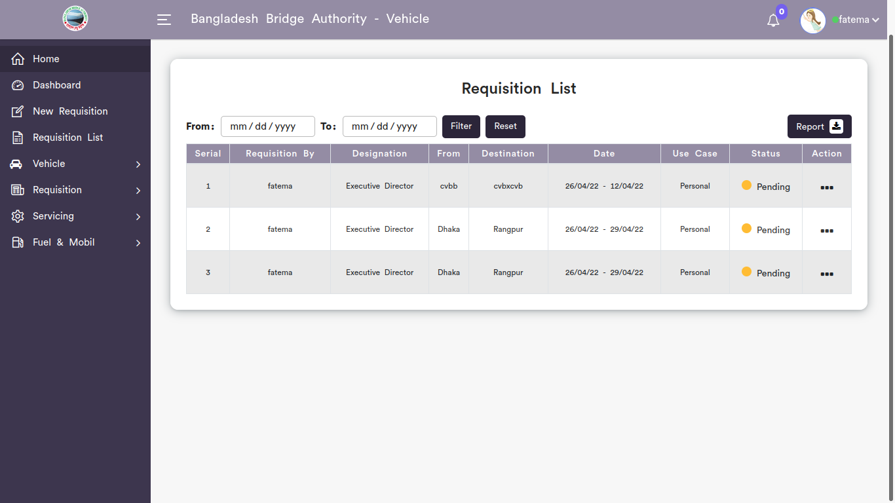

*Positive test case*

|  |  |  |  |  |  |
| --- | --- | --- | --- | --- | --- |
| Case ID | Title | Description | Expected Result | Actual Result | Pass/Fail |
| 1 | Requisition List | Display all the requisition list information | Displayed all information | No missing | P |
| 2 | Modifying List | Click update for updating any specific requisition | Updated existing database | No error | P |
| 3 | Report | Report is generated in excell format | Generate | Saved | P |

*Negative Test Case*

|  |  |  |  |  |  |
| --- | --- | --- | --- | --- | --- |
| Case ID | Title | Description | Expected Result | Actual Result | Pass/Fail |
| 1 | Requisition List | 1. A range of information should display by selecting a specific date  2. action button should work fine | No missing information | No error | P |
| 2 | Modifying List | Update button should update the existing information proeprly | updated | No error while updating | P |
| 3 | Report | Excell form should have proper information | Generated the file | Saved or downloaded | P |

**For Transport Admin:**

**Test Scenario 4: Vehicle**

1. Vehicle Record

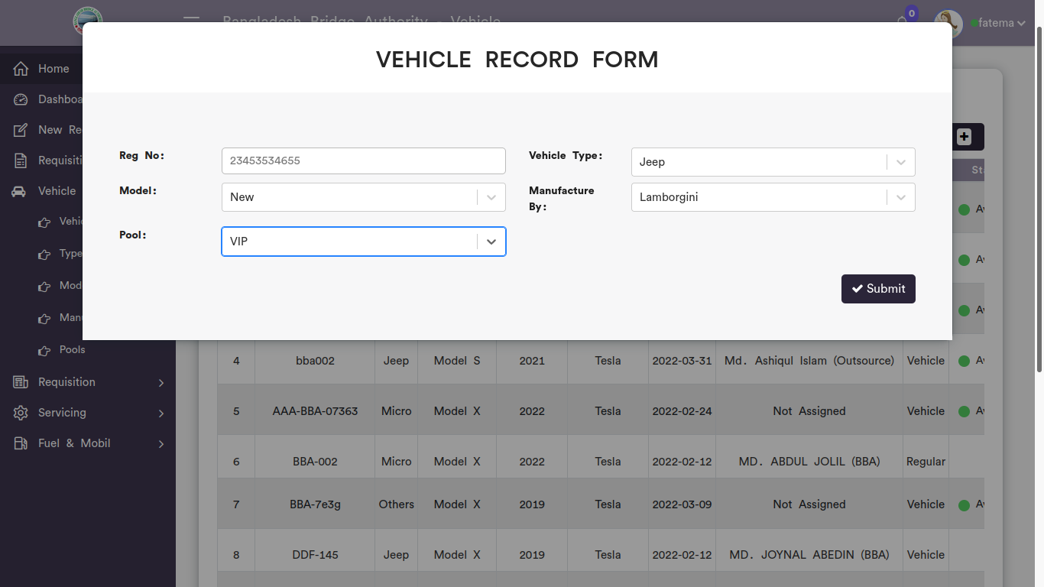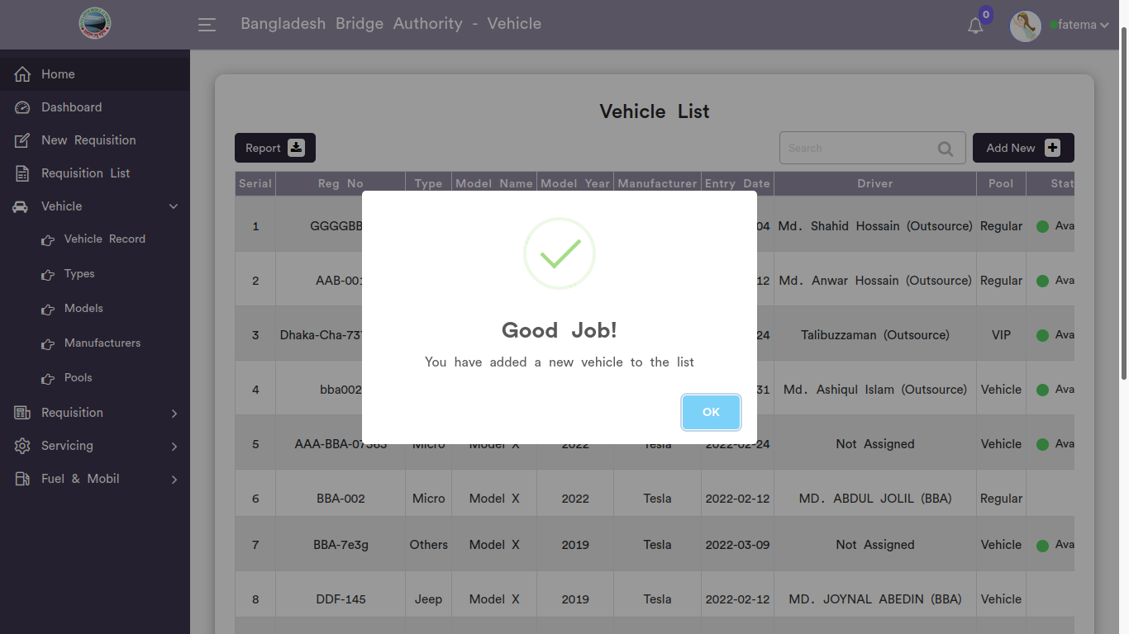

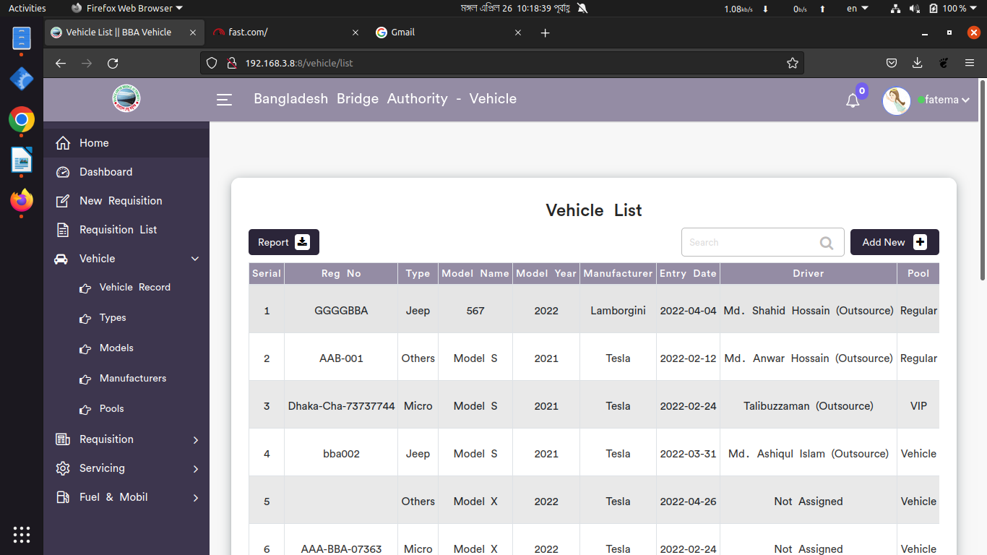

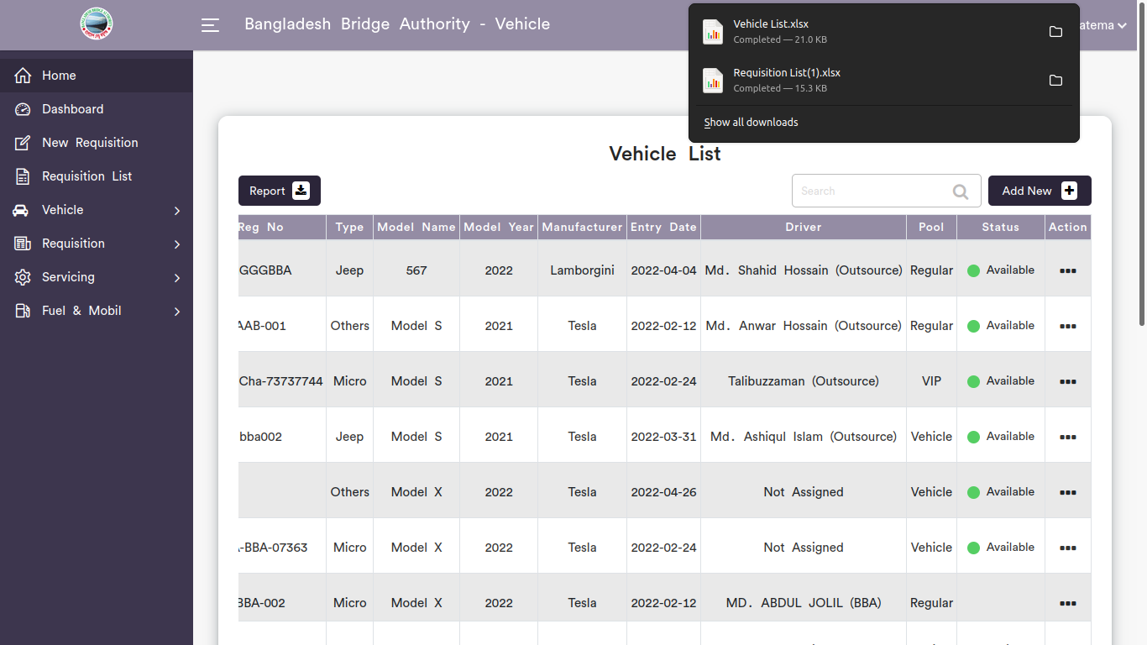

*Positive test case*

|  |  |  |  |  |  |
| --- | --- | --- | --- | --- | --- |
| Case ID | Title | Description | Expected Result | Actual Result | Pass/Fail |
| 1 | Add new | 1. Enter vehicle registration no.  2. Select vehicle type, model, manufacturer & pool  3. Click submit | Data saved successfully | No error while saving | P |
| 2 | Vehicle List | Display all the vehicle information | All information are displayed | No information is missing | P |
| 3 | Update | 1. Update the existing information  2. Update the driver information for a vehicle  3. click update | Updated database | No error while updating | P |
| 4 | Report | Report generated in xcell | Generated | saved | P |

*Negative Test Case*

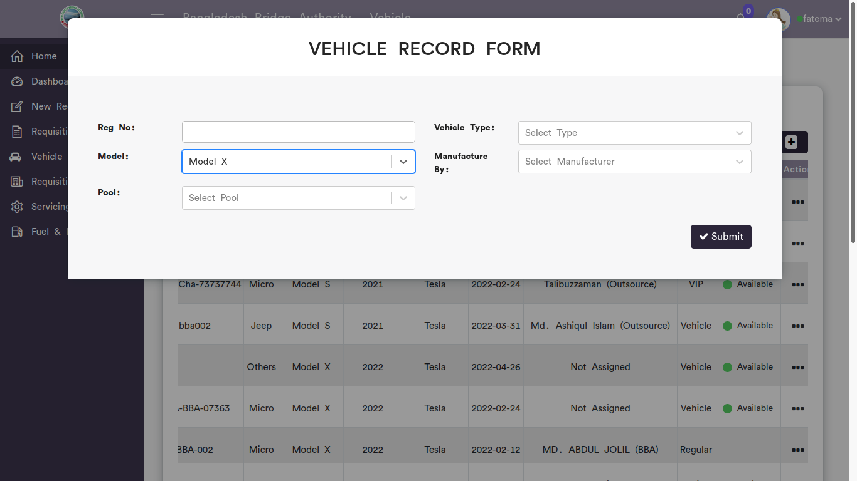

|  |  |  |  |  |  |
| --- | --- | --- | --- | --- | --- |
| Case ID | Title | Description | Expected Result | Actual Result | Pass/Fail |
| 1 | Add new | 1. Reg no should be valid  2. Data should be selected  3. submit button should store the vehicle information | Data checked | No error | P |
| 2 | Vehicle List | checked all the vehicle information is displayed without any missing | No missing information | No error occurred while displaying | P |
| 3 | Update | Information should update for current given information | Updated existing information | Perfectly executed | P |
| 4 | Report | Xcell document must be downloaded | Generated report | No error while saving the file | P |

2. Vehicle Types

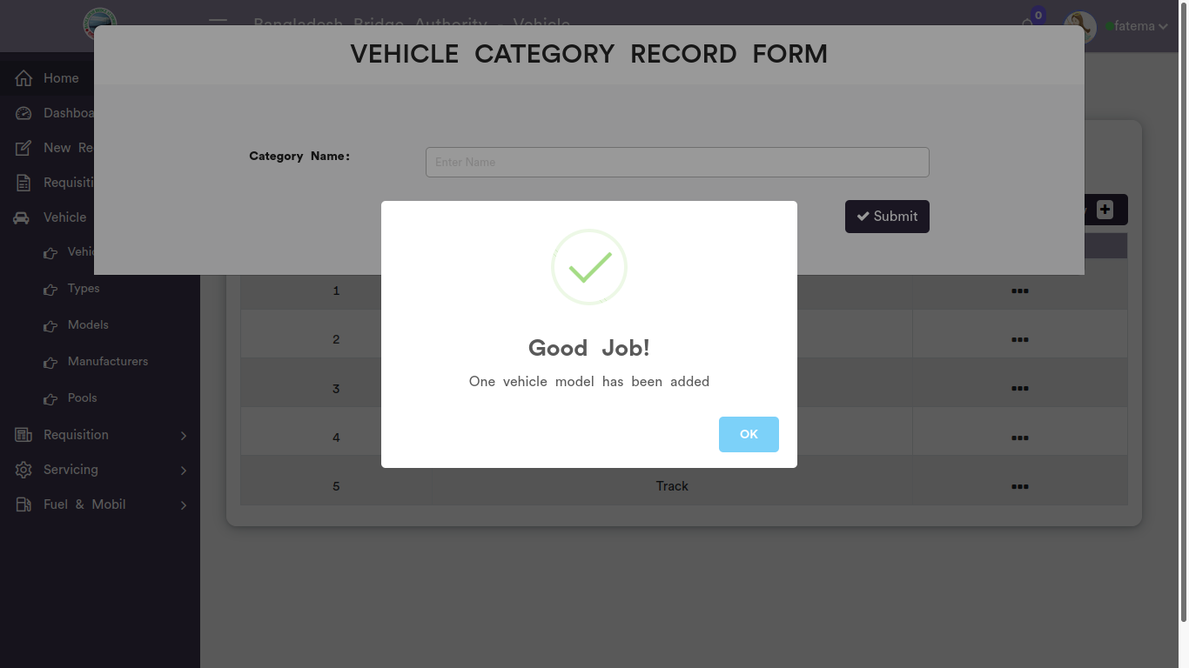

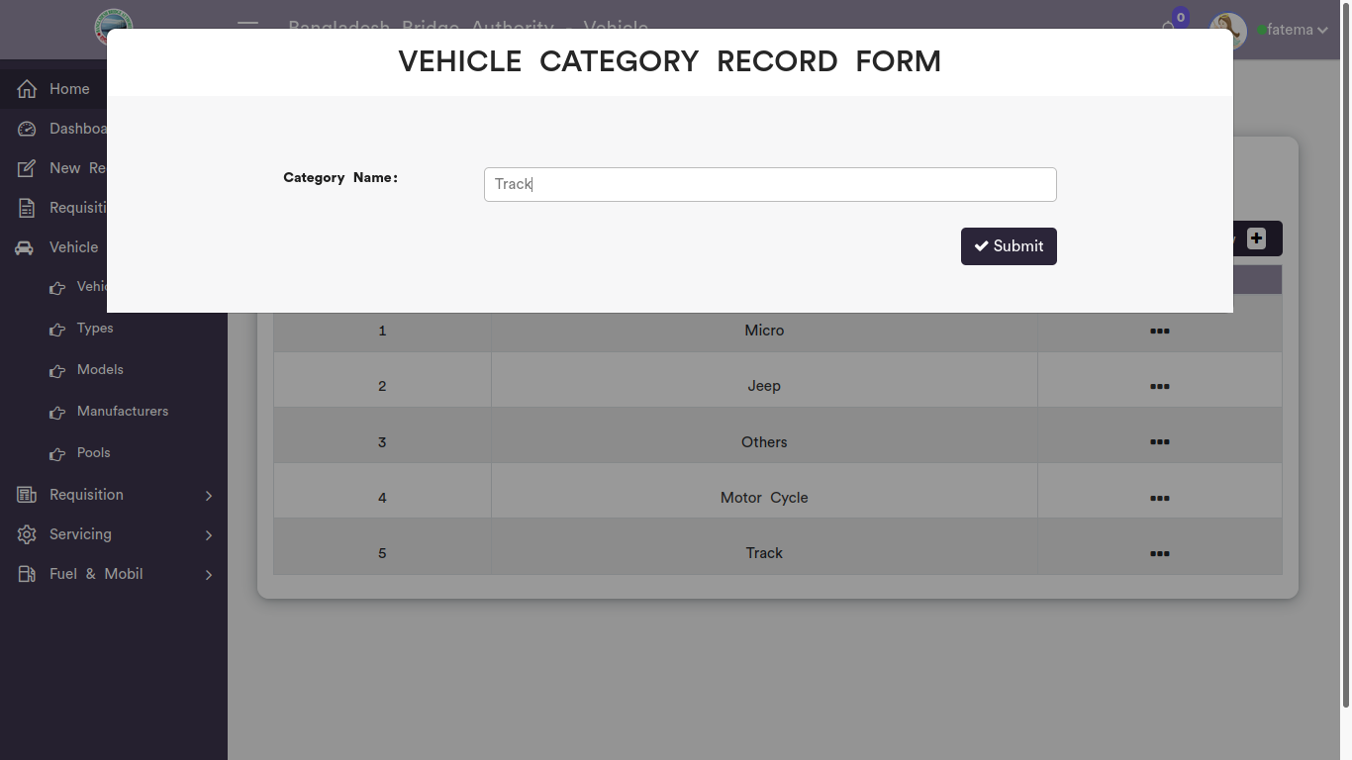

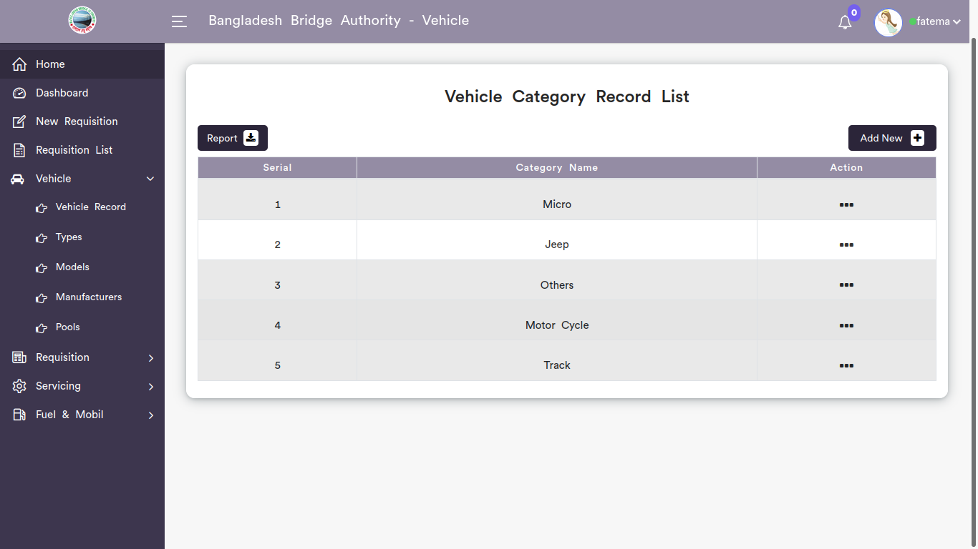

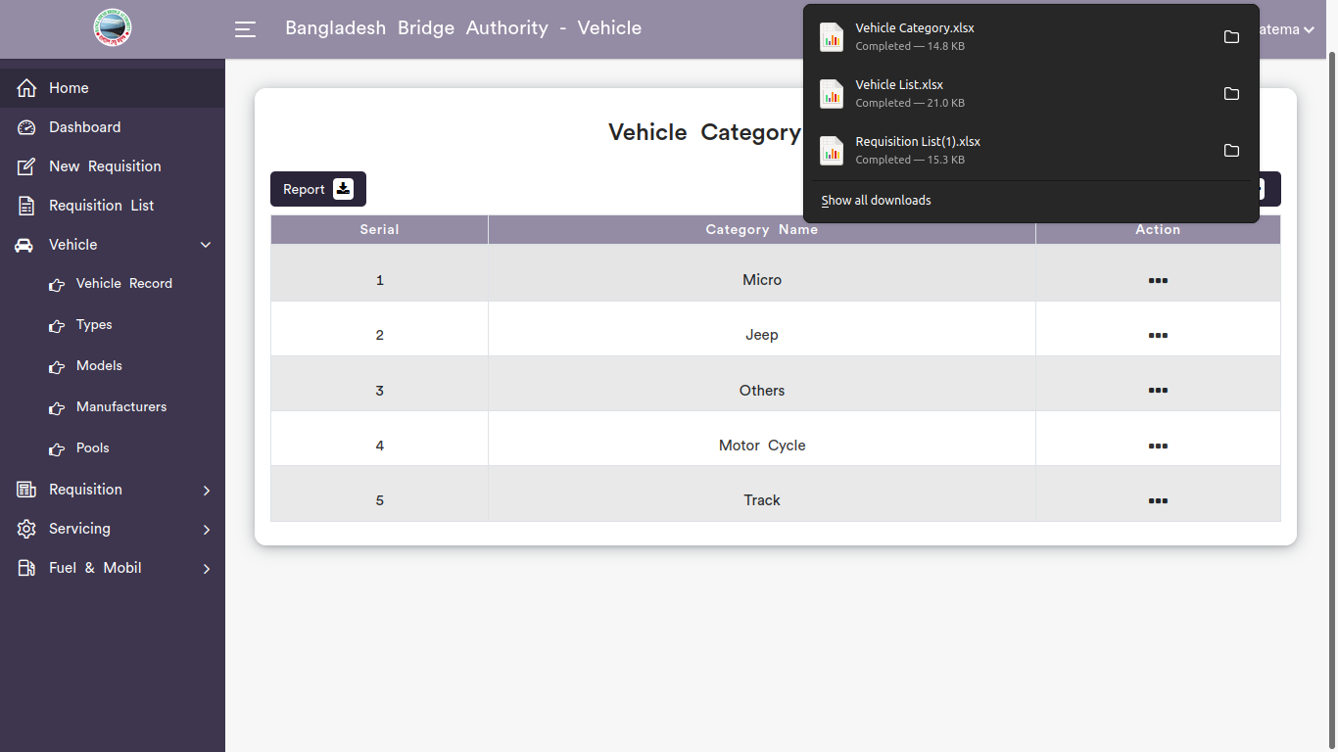

*Positive test case*

|  |  |  |  |  |  |
| --- | --- | --- | --- | --- | --- |
| Case ID | Title | Description | Expected Result | Actual Result | Pass/Fail |
| 1 | Add New | 1. Enter Category name  2. Click submit | Data saved successfully | No error while saving | P |
| 2 | Vehicle Category Record List | Display all vehicle category list | All information are displayed | No information is missing | P |
| 3 | Update | Update the existing information | Updated database | No error while updating | P |
| 4 | Report | Report generated in xcell | Generated | saved | P |

*Negative Test Case*

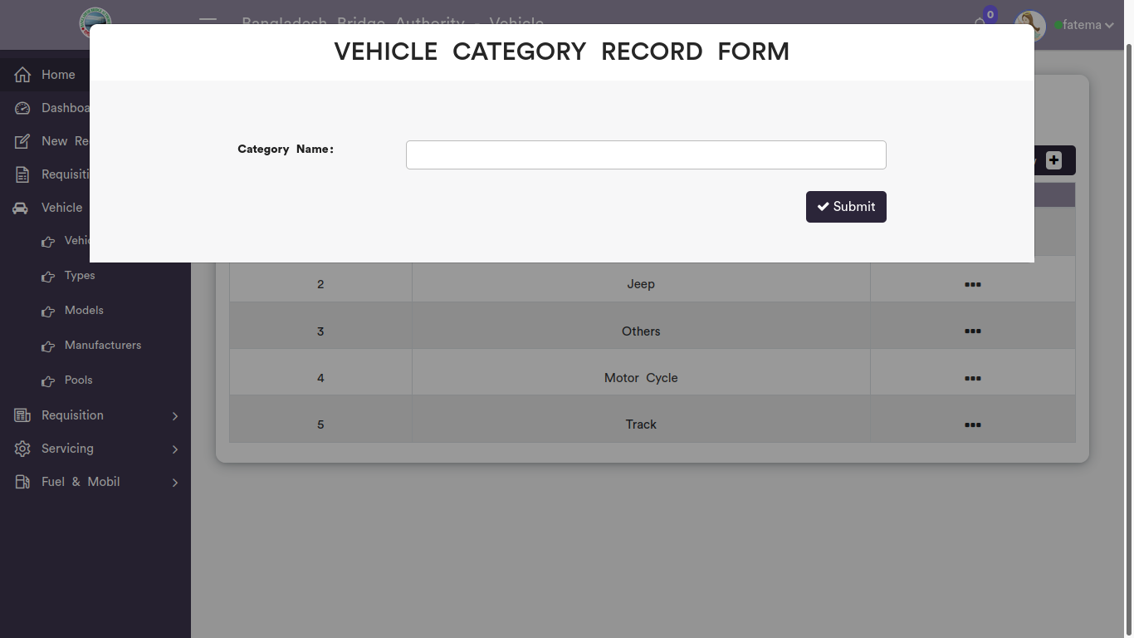

|  |  |  |  |  |  |
| --- | --- | --- | --- | --- | --- |
| Case ID | Title | Description | Expected Result | Actual Result | Pass/Fail |
| 1 | Add New | 1. No name can’t created in model type  2. submit button should store new vehicle type | Data checked | No error | P |
| 2 | Vehicle Category Record List | Checked all the information is displayed or not | No missing information | No error occurred while displaying | P |
| 3 | Update | Checked update button replacing the existing information or not | Updated existing information | Perfectly executed | P |
| 4 | Report | Xcell form can be downloaded | Generated report | No error while saving the file | P |

3. Vehicle Models

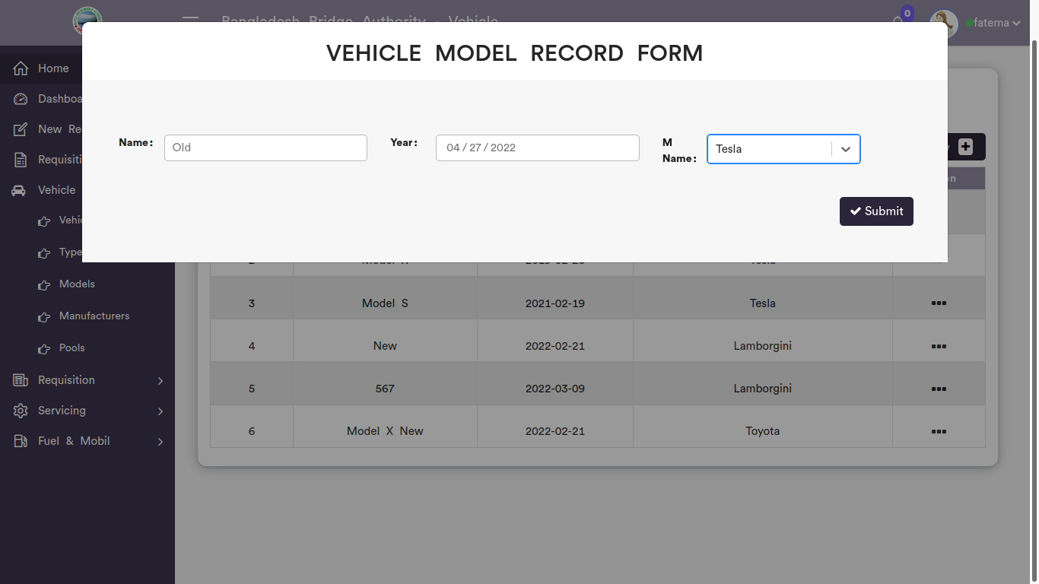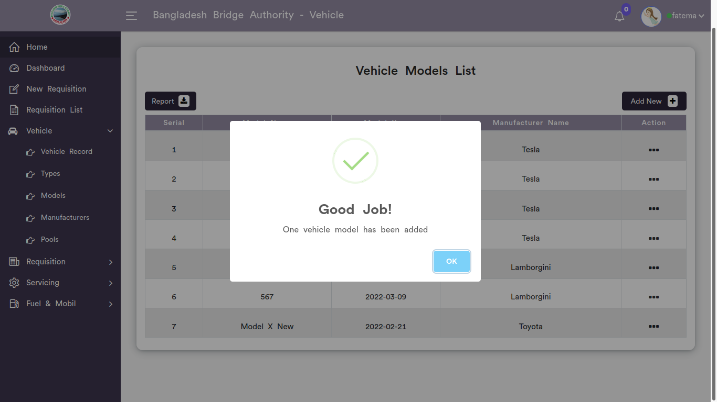

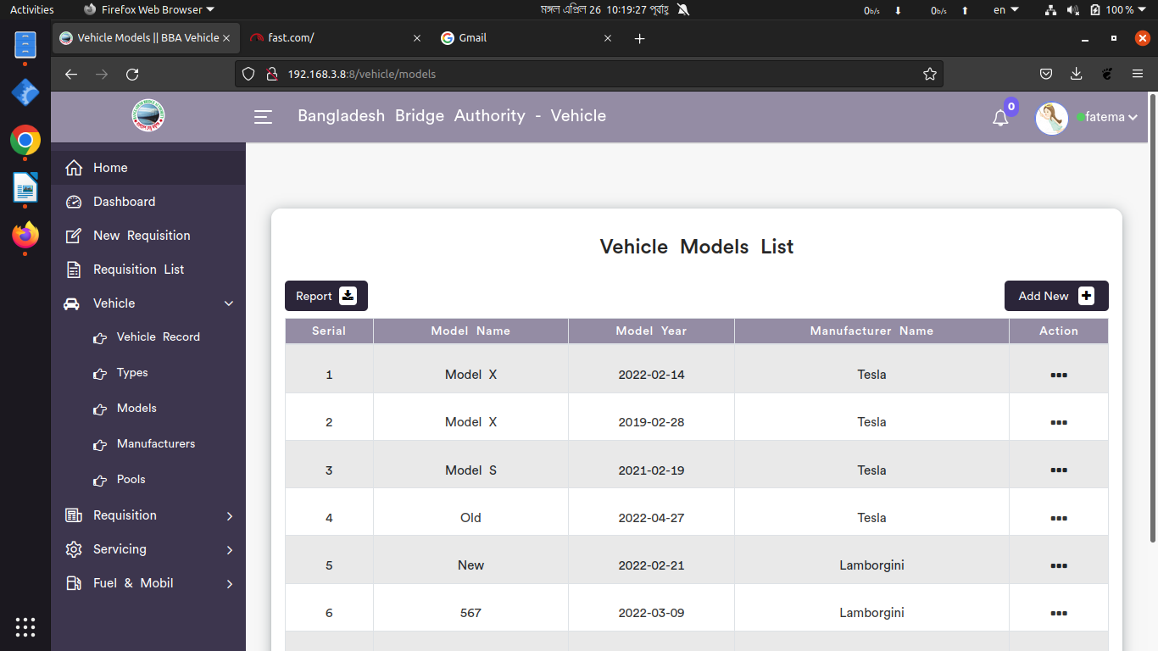

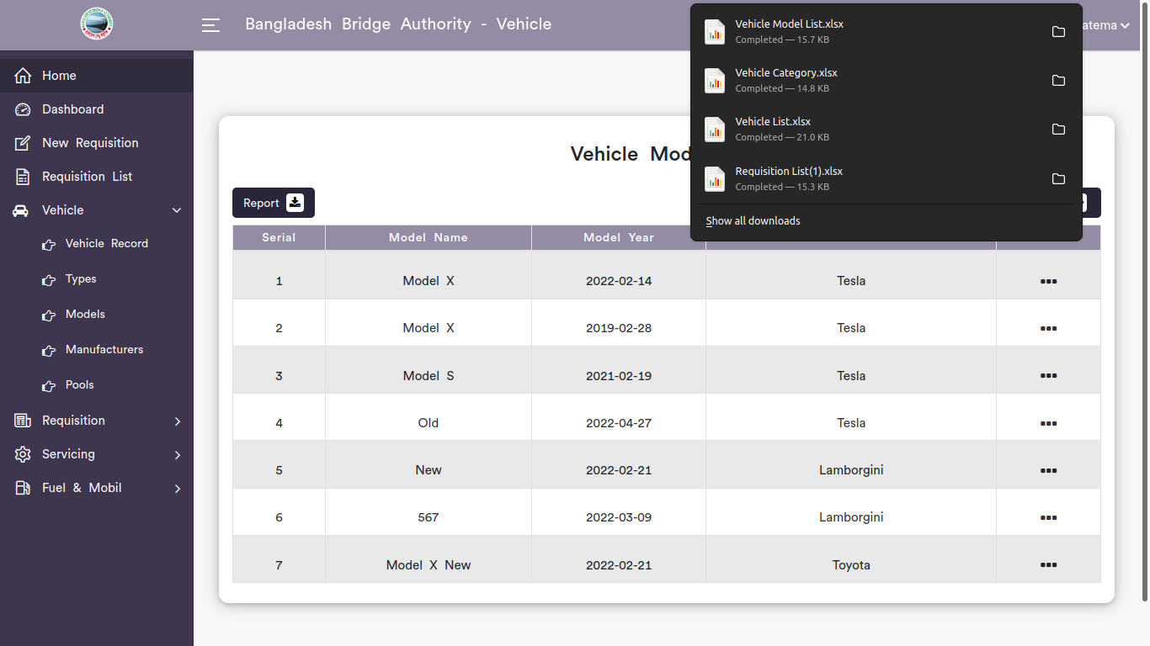

*Positive test case*

|  |  |  |  |  |  |
| --- | --- | --- | --- | --- | --- |
| Case ID | Title | Description | Expected Result | Actual Result | Pass/Fail |
| 1 | Add new | 1. Enter vehicle model name  2. Select date & manufacturer  3. Click submit | Data saved successfully | No error while saving | P |
| 2 | Vehicle models List | Display all the vehicle model information | All information are displayed | No information is missing | P |
| 3 | Update | Update button does the replacement of existing information | Updated database | No error while updating | P |
| 4 | Report | Generated in XCELL | Generated | saved | P |

*Negative Test Case*

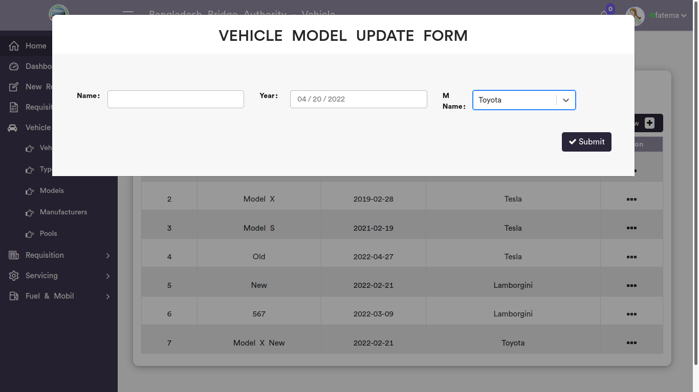

|  |  |  |  |  |  |
| --- | --- | --- | --- | --- | --- |
| Case ID | Title | Description | Expected Result | Actual Result | Pass/Fail |
| 1 | Vehicle models List | 1. Vehicle model name should fill up  2. Date should be valid & manufacturer should be selected  3. submit should work fine | Data checked | No error | P |
| 2 | View | Display all the vehicle model information without any missing | No missing information | No error occurred while displaying | P |
| 3 | Update | Update button should update database | Updated existing information | Perfectly executed | P |
| 4 | Report | Xcell file must be downloaded | Generated report | No error while saving the file | P |

3. Vehicle Manufacturers

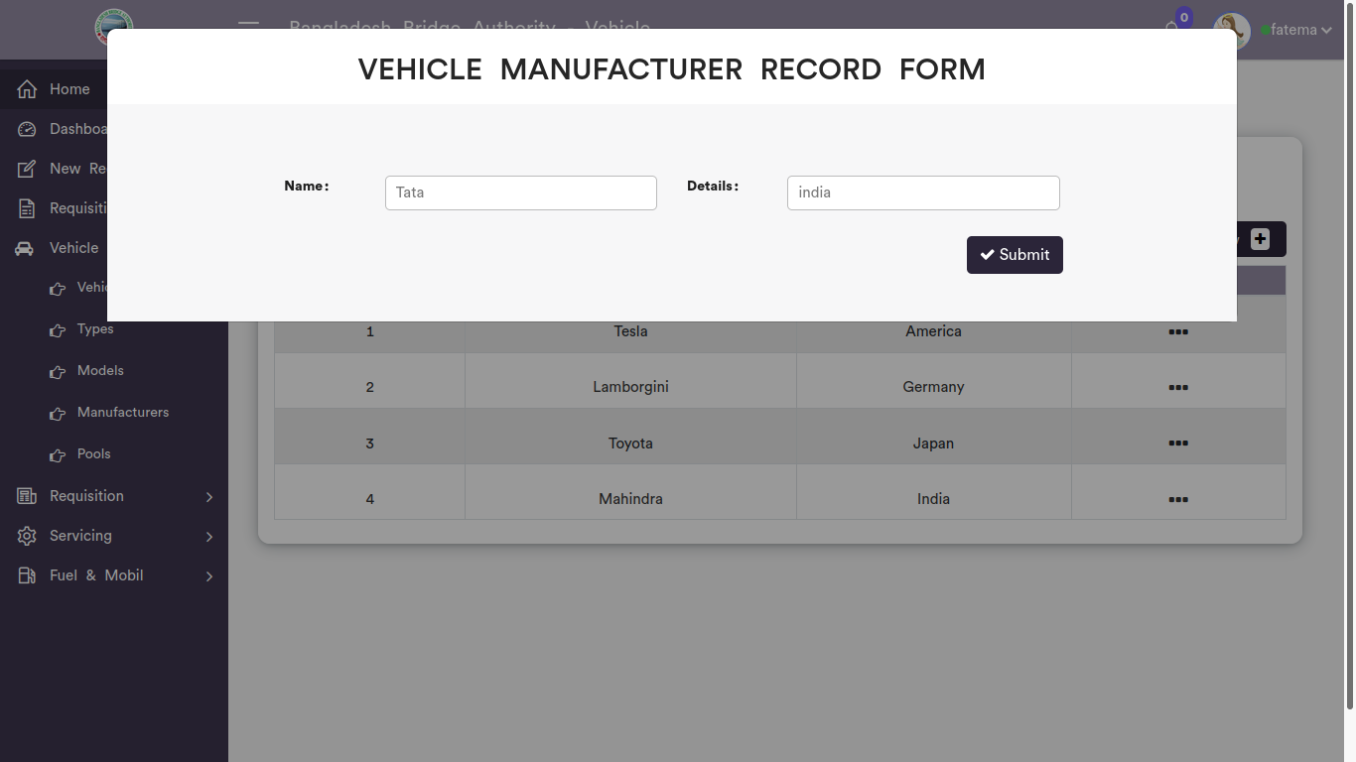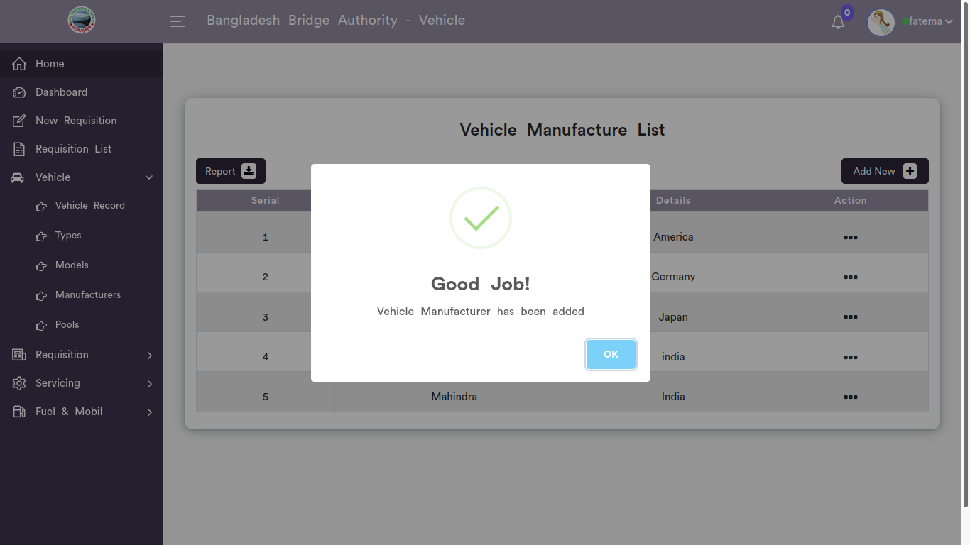

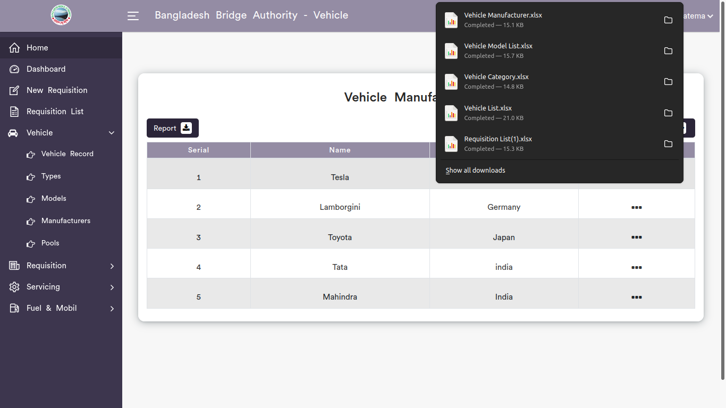

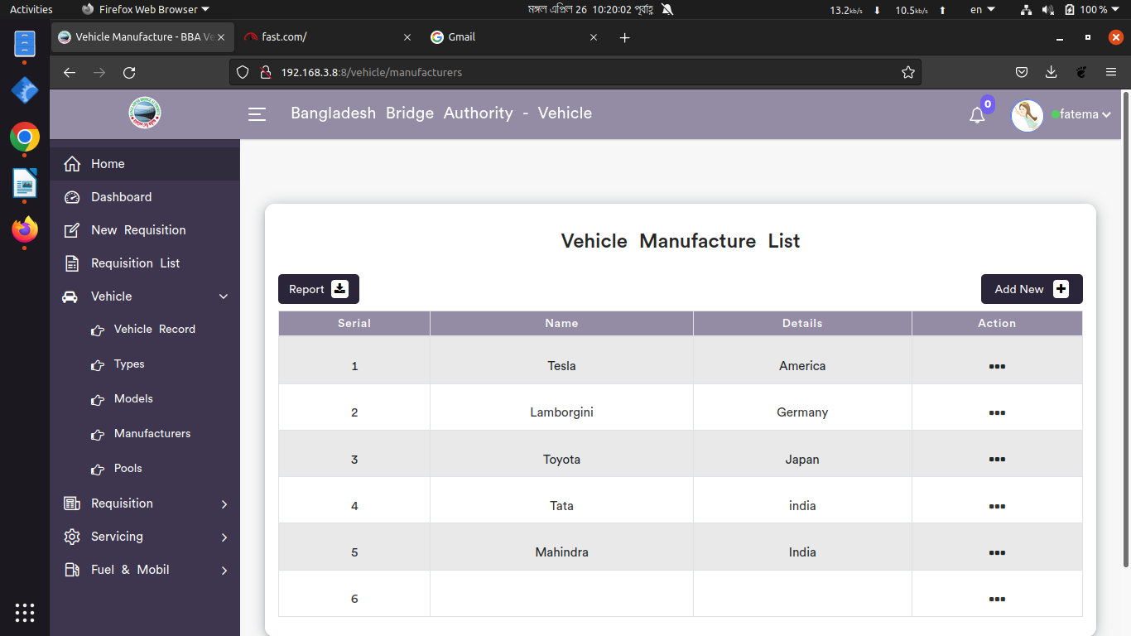

*Positive test case*

|  |  |  |  |  |  |
| --- | --- | --- | --- | --- | --- |
| Case ID | Title | Description | Expected Result | Actual Result | Pass/Fail |
| 1 | Add new | 1. Enter manufacturer name & their details information  2. Click submit | Data saved successfully | No error while saving | P |
| 2 | Vehicle manufacturers List | Show all the manufacturer name | All information are displayed | No information is missing | P |
| 3 | Update | Update button does the replacement of existing manufacturer information | Updated database | No error while updating | P |
| 4 | Report | Generated in excell file | Generated | saved | P |

*Negative Test Case*

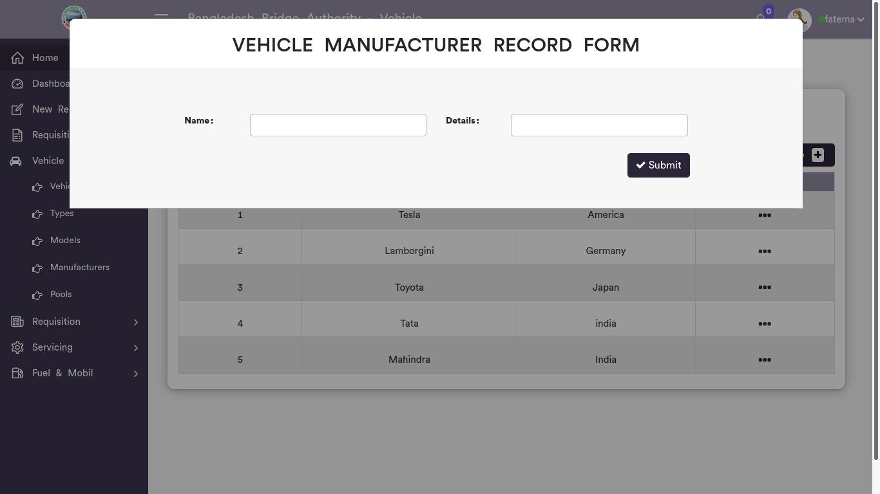

|  |  |  |  |  |  |
| --- | --- | --- | --- | --- | --- |
| Case ID | Title | Description | Expected Result | Actual Result | Pass/Fail |
| 1 | Add new | 1. Must fiill up the form  2. Submit button should store information | Data checked | No error | P |
| 2 | Vehicle manufacturers List | No information should be missing | No missing information | No error occurred while displaying | P |
| 3 | Update | Update button should work fine | Updated existing information | Perfectly executed | P |
| 4 | Report | Xcell file can be downloaded | Generated report | No error while saving the file | P |

5. Pools

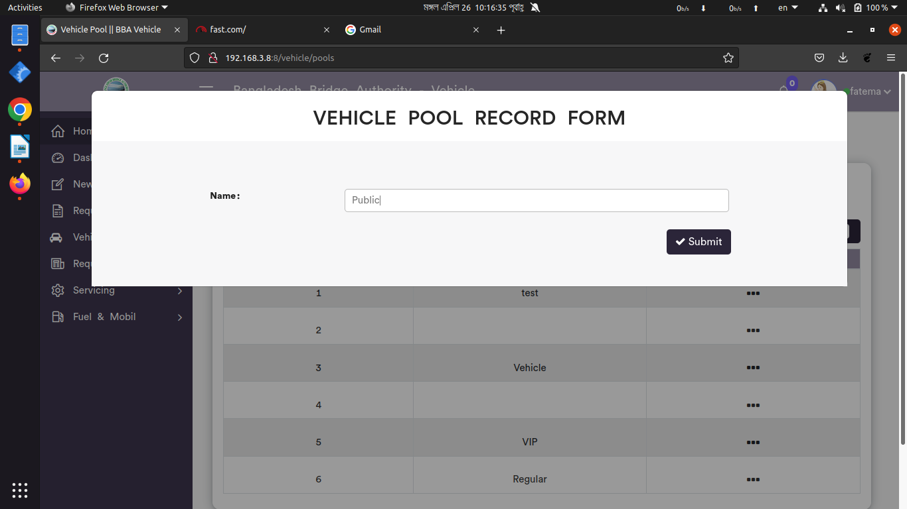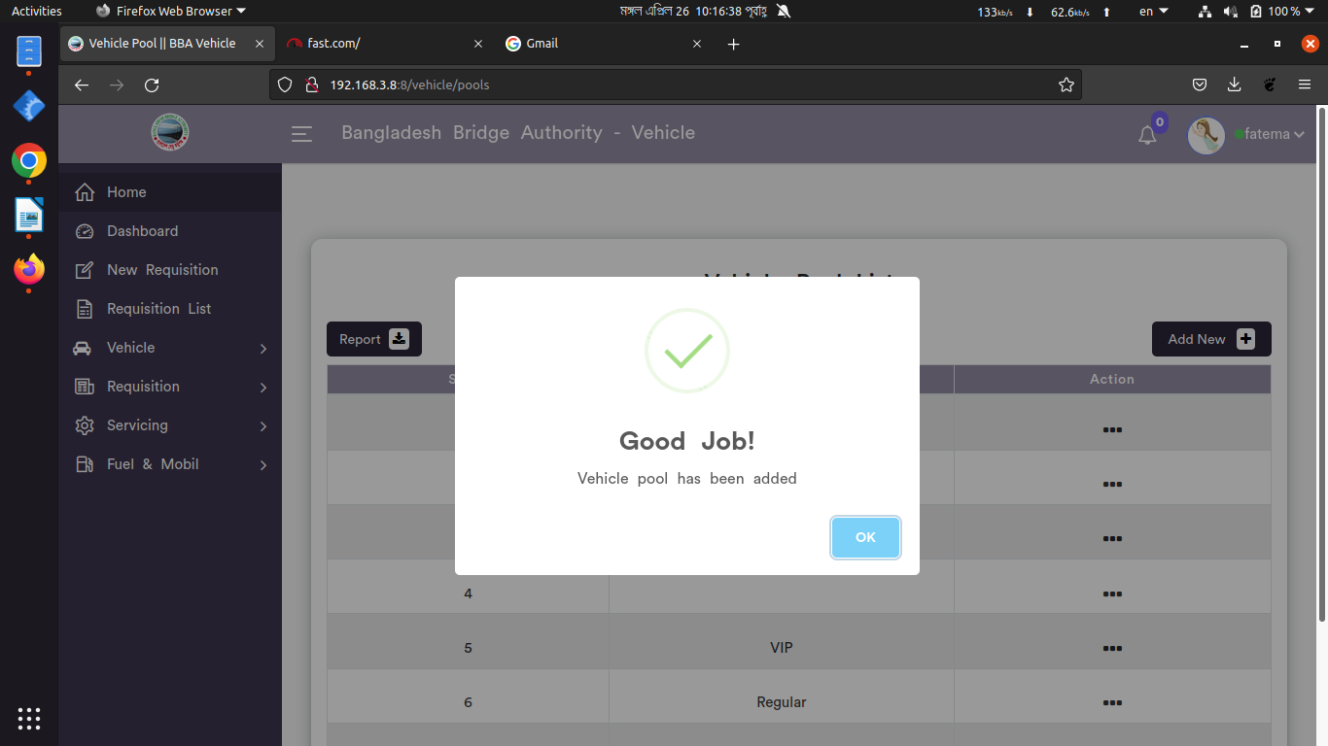

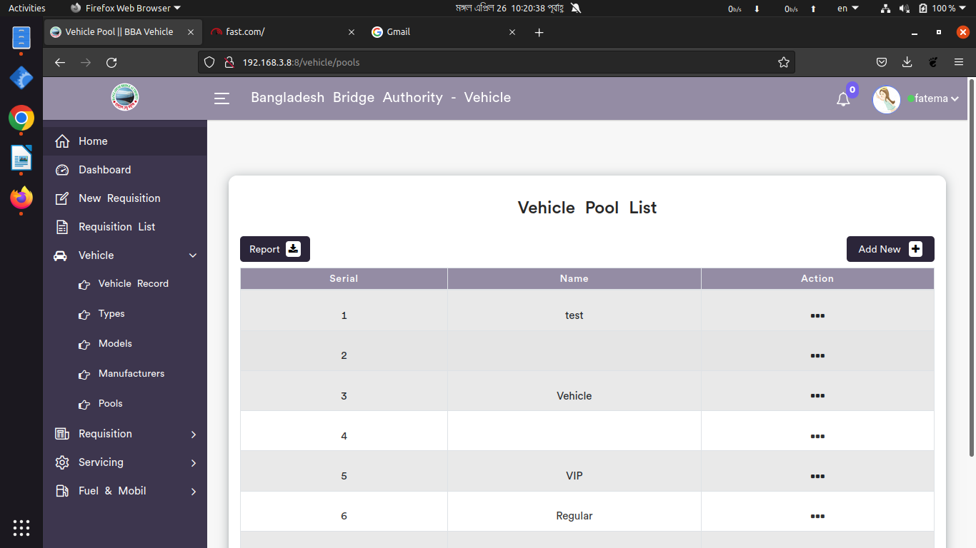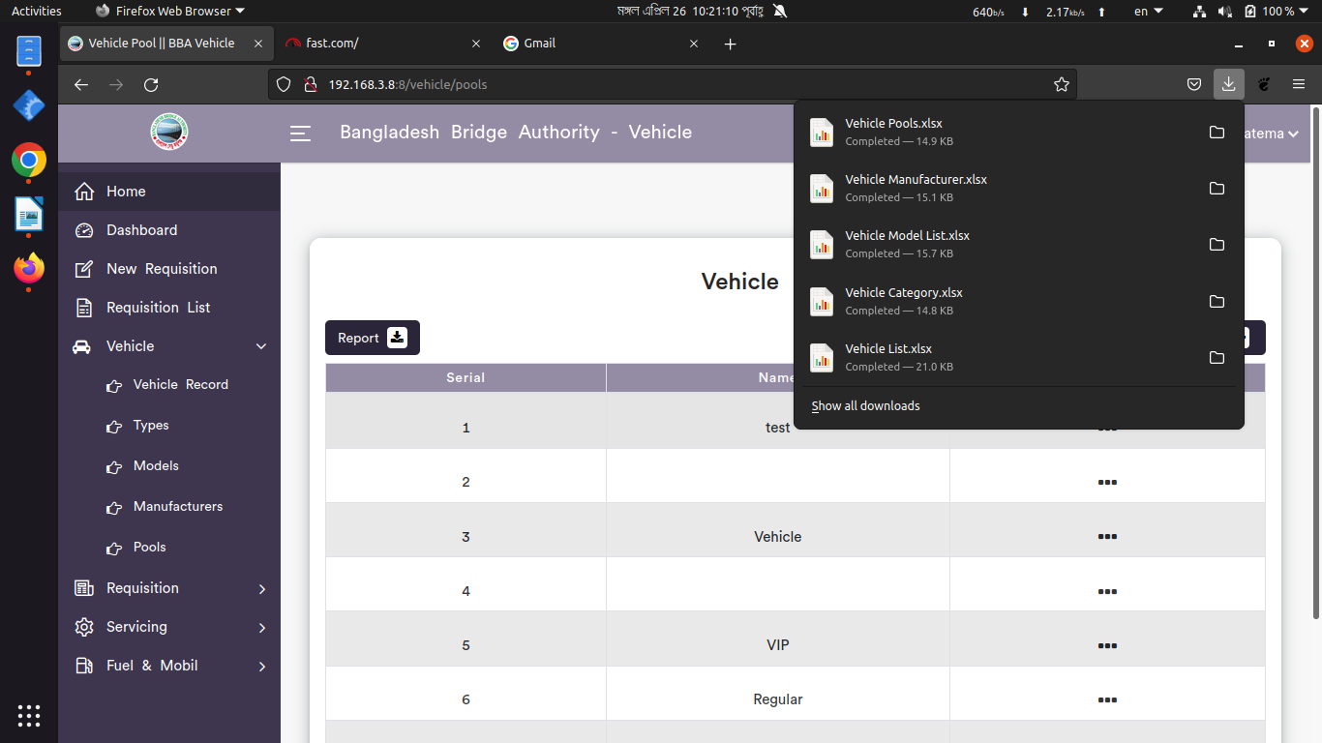

*Positive test case*

|  |  |  |  |  |  |
| --- | --- | --- | --- | --- | --- |
| Case ID | Title | Description | Expected Result | Actual Result | Pass/Fail |
| 1 | Add new | 1. Enter vehicle pool name  2. Click submit | Data saved successfully | No error while saving | P |
| 2 | Vehicle pool List | Show all the vehicle pool information | All information are displayed | No information is missing | P |
| 3 | Update | Update the existing information | Updated database | No error while updating | P |
| 4 | Report | Generated in Xcell format | Generated | saved | P |

*Negative Test Case*

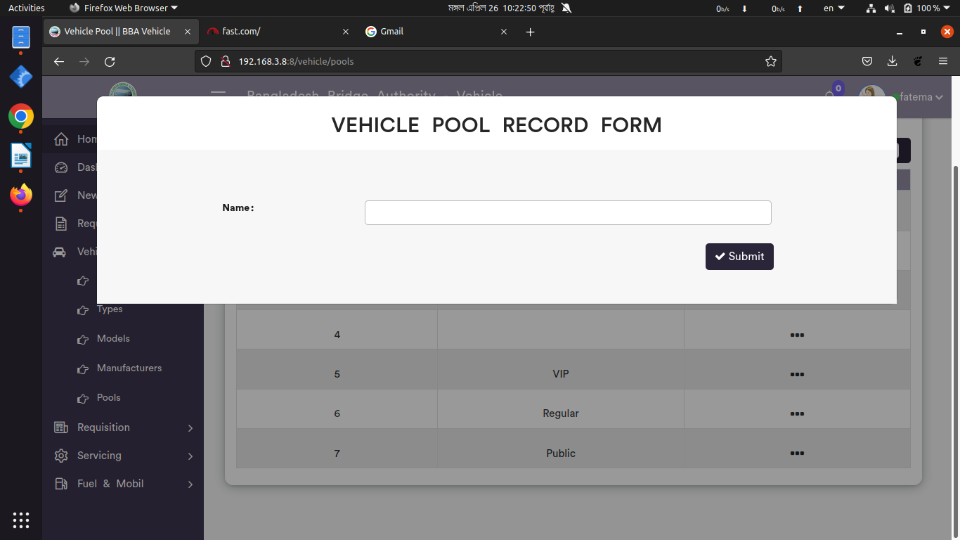

|  |  |  |  |  |  |
| --- | --- | --- | --- | --- | --- |
| Case ID | Title | Description | Expected Result | Actual Result | Pass/Fail |
| 1 | Add new | 1. Form should fill up  2. Submit button should perfectly work | Data checked | No error | P |
| 2 | Vehicle pool List | No information is missing | No missing information | No error occurred while displaying | P |
| 3 | Update | Update the existing information in the list | Updated existing information | Perfectly executed | P |
| 4 | Report | Xcell file can be downloaded | Generated report | No error while saving the file | P |

**Test Scenario 6: Requisition**

1. Requisition Record

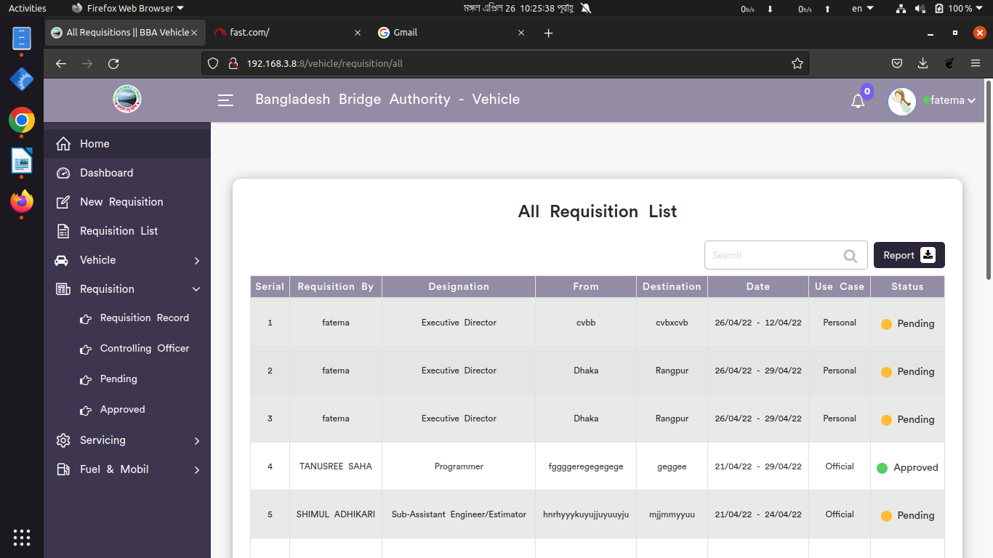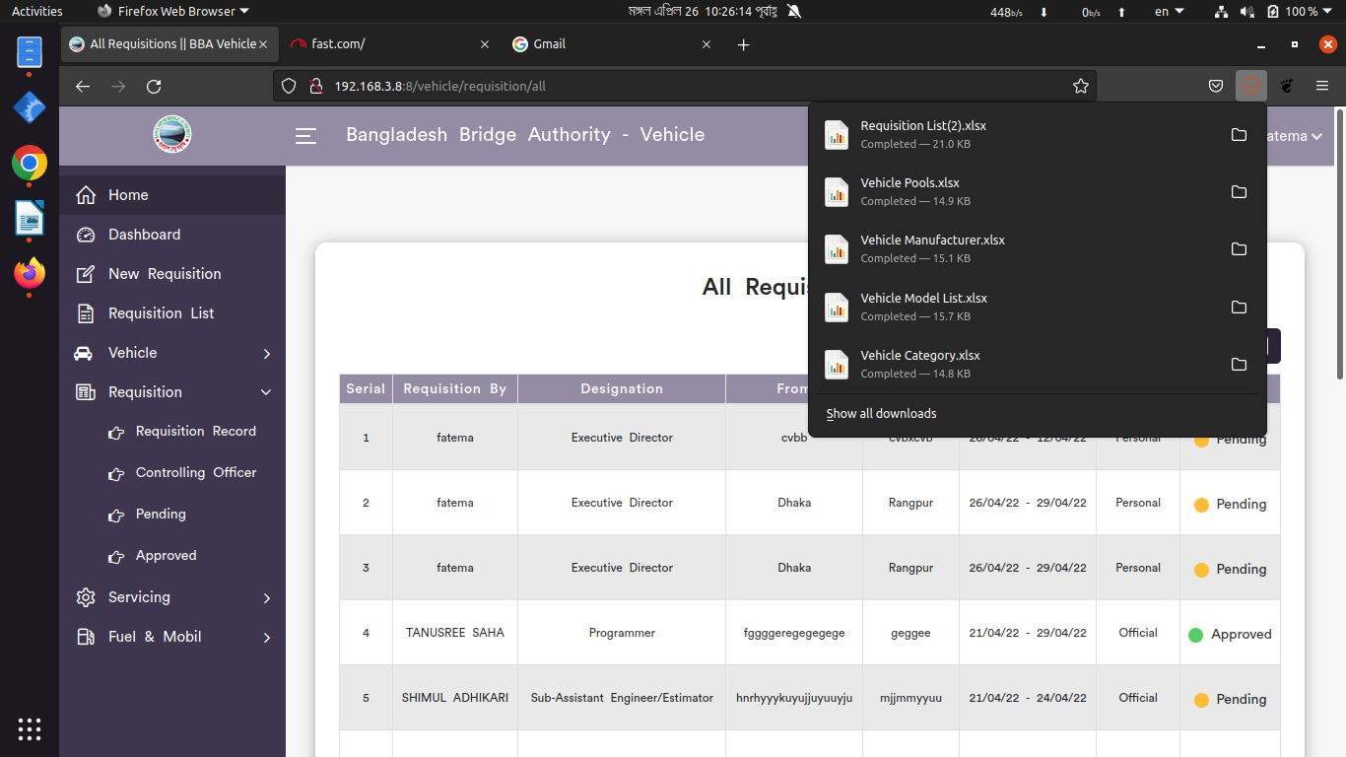

*Positive test case*

|  |  |  |  |  |  |
| --- | --- | --- | --- | --- | --- |
| Case ID | Title | Description | Expected Result | Actual Result | Pass/Fail |
| 1 | All Requisition List | Show All the requisition list and their current status | Displayed all information | No missing | P |
| 2 | Report | Report of these requisition can be generated in xcell format | Generated | Saved | P |

*Negative Test Case*

|  |  |  |  |  |  |
| --- | --- | --- | --- | --- | --- |
| Case ID | Title | Description | Expected Result | Actual Result | Pass/Fail |
| 1 | All Requisition List | All requisition status should be displayed | No missing | No error occurred while displaying | P |
| 2 | Report | Xcell file must be downloaded | Generated file | Downloaded as document format | P |

2. Controlling officer

*Positive test case*

|  |  |  |  |  |  |
| --- | --- | --- | --- | --- | --- |
| Case ID | Title | Description | Expected Result | Actual Result | Pass/Fail |
| 1 | Pending Requisition for controlling officer | Show All the pending requisition list and their current status | Displayed all information | No missing | P |
| 2 | Report | Report of these requisition can be generated in xcell format | Generated | Saved | P |

*Negative Test Case*

|  |  |  |  |  |  |
| --- | --- | --- | --- | --- | --- |
| Case ID | Title | Description | Expected Result | Actual Result | Pass/Fail |
| 1 | Pending Requisition for controlling officer | All pending requisition status should be displayed | No missing | No error occurred while displaying | P |
| 2 | Report | Xcell file must be downloaded | Generated file | Downloaded as document format | P |

2. Pending Requisition

*Positive test case*

|  |  |  |  |  |  |
| --- | --- | --- | --- | --- | --- |
| Case ID | Title | Description | Expected Result | Actual Result | Pass/Fail |
| 1 | Pending Requisition list | Show All the pending requisition list and their current status | Displayed all information | No missing | P |
| 2 | Report | Report of these requisition can be generated in xcell format | Generated | Saved | P |

*Negative Test Case*

|  |  |  |  |  |  |
| --- | --- | --- | --- | --- | --- |
| Case ID | Title | Description | Expected Result | Actual Result | Pass/Fail |
| 1 | Pending Requisition List | All pending requisition status should be displayed | No missing | No error occurred while displaying | P |
| 3 | Report | Xcell file must be downloaded | Generated file | Downloaded as document format | P |

4. Approved Requisition List

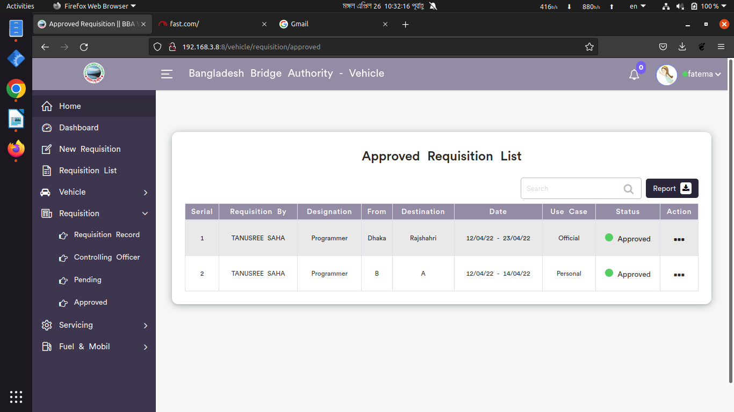

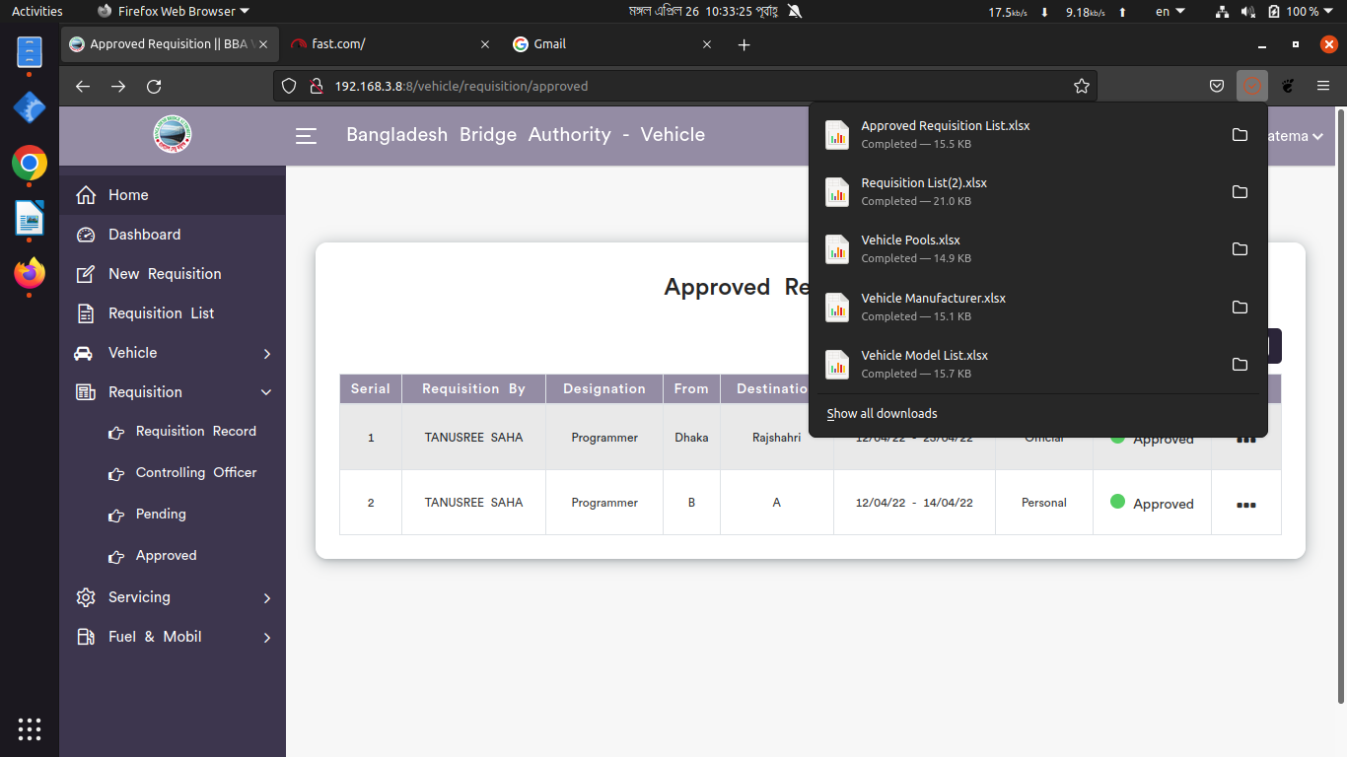

*Positive test case*

|  |  |  |  |  |  |
| --- | --- | --- | --- | --- | --- |
| Case ID | Title | Description | Expected Result | Actual Result | Pass/Fail |
| 1 | Approved Requisition List | Show All the approved requisition list and their current status | Displayed all information | No missing | P |
| 2 | Report | Report of these requisition can be generated in xcell format | Generated | Saved | P |

*Negative Test Case*

|  |  |  |  |  |  |
| --- | --- | --- | --- | --- | --- |
| Case ID | Title | Description | Expected Result | Actual Result | Pass/Fail |
| 1 | Approved Requisition List | All approved requisition status should be displayed | No missing | No error occurred while displaying | P |
| 2 | Report | Xcell file must be downloaded | Generated file | Downloaded as document format | P |

**Test Scenario 7: Servicing**

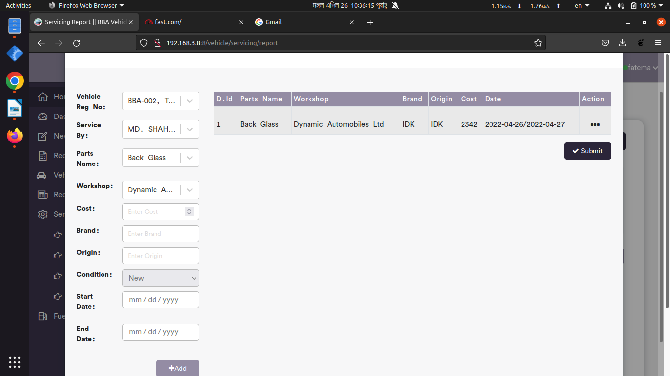1. Servicing Record

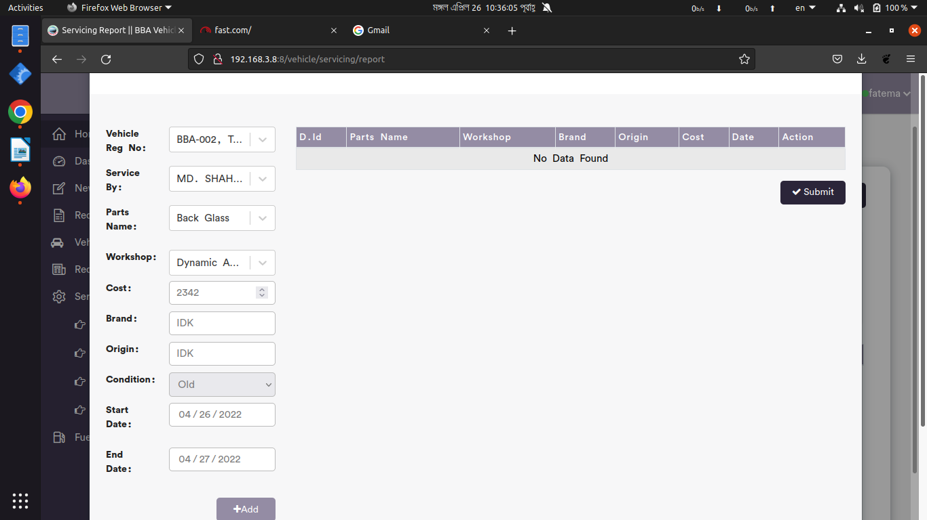

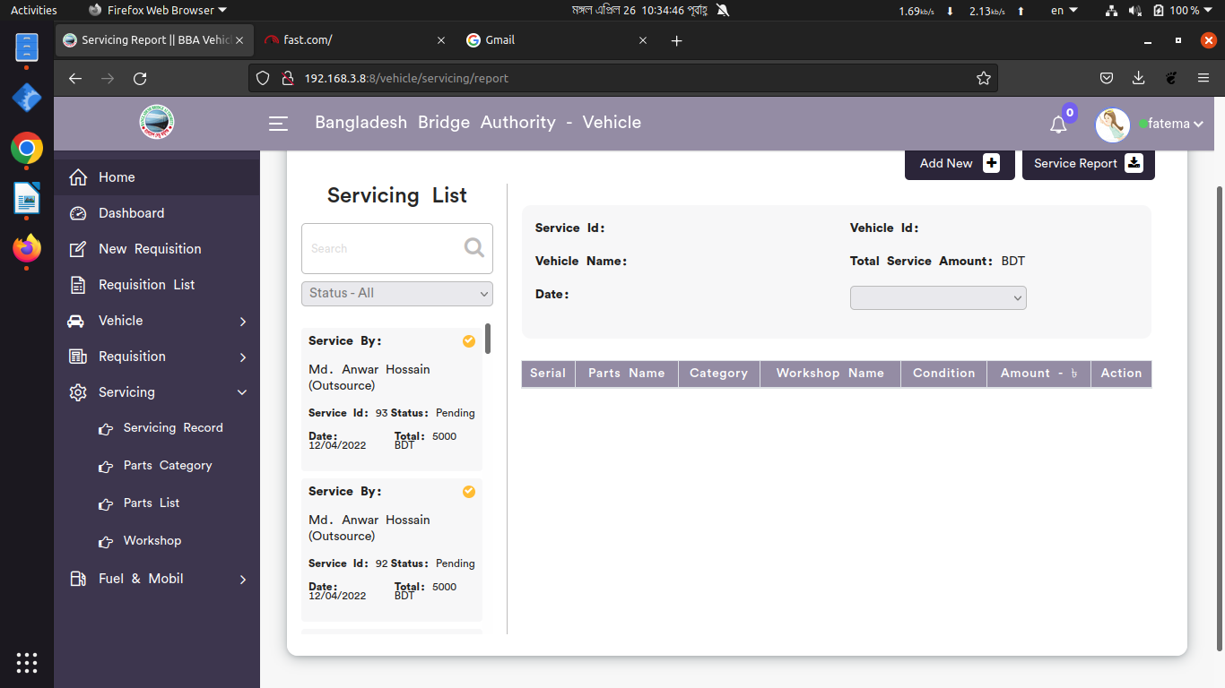

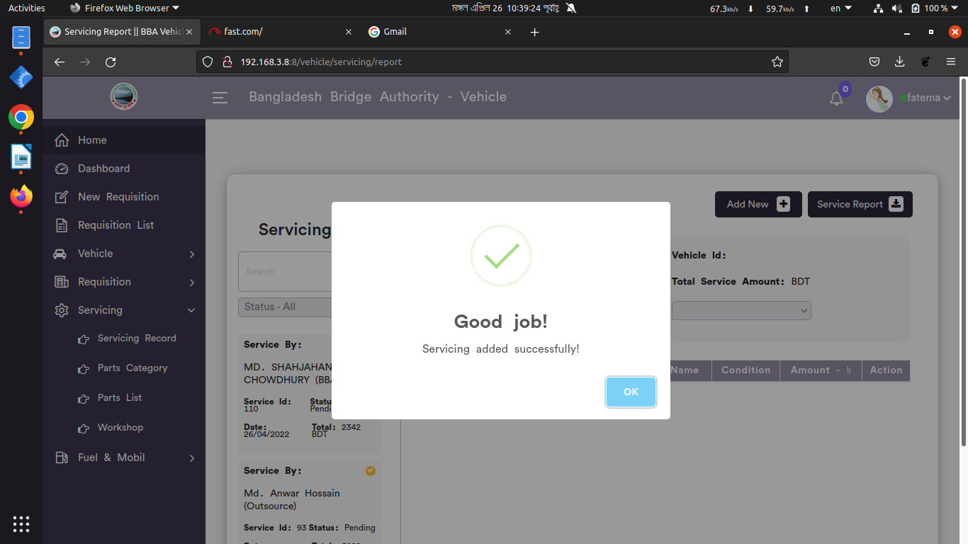

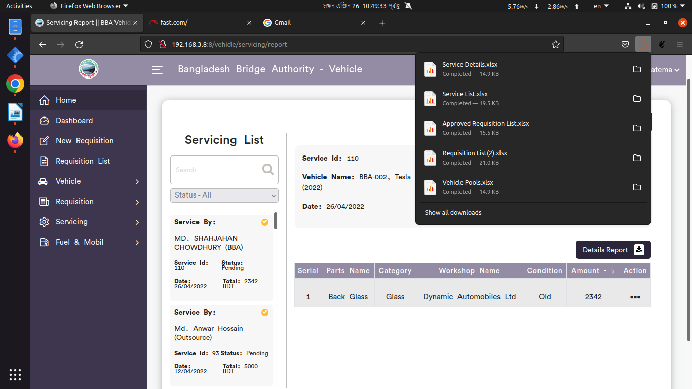

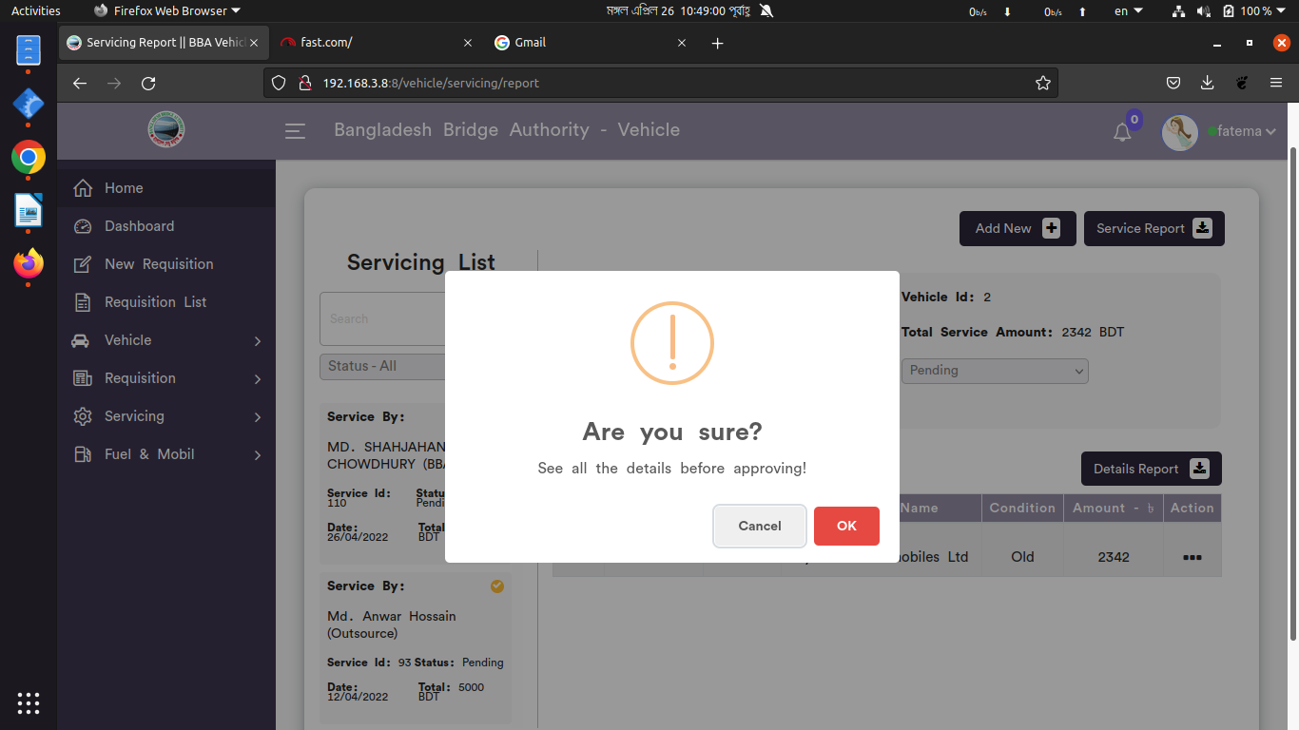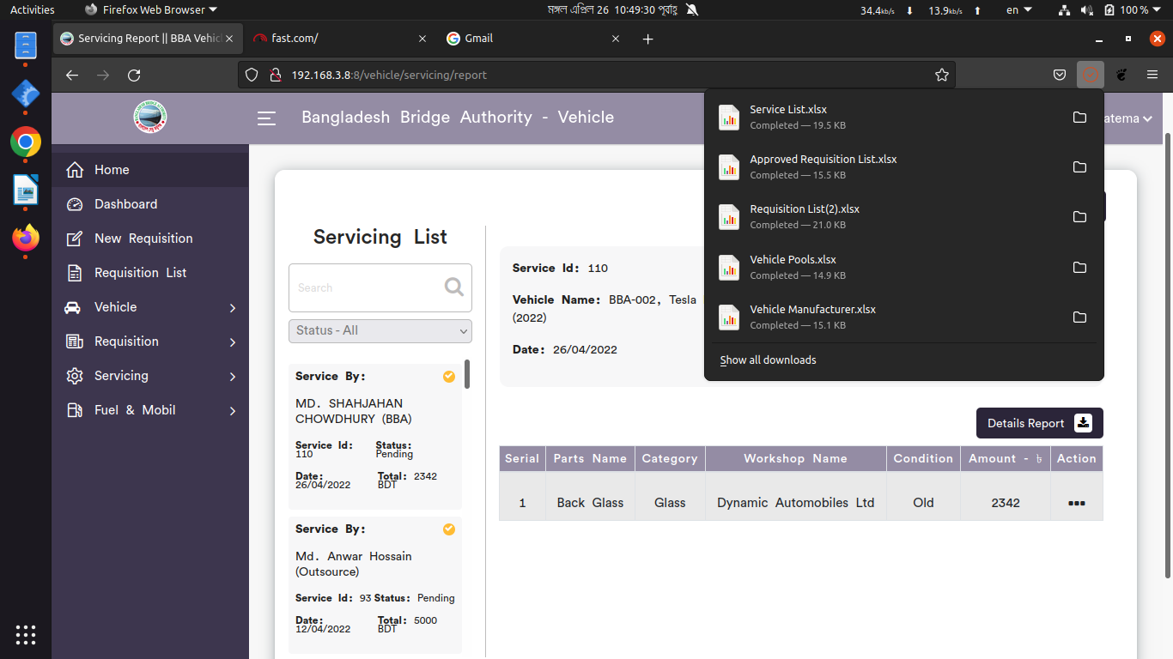

*Positive test case*

|  |  |  |  |  |  |
| --- | --- | --- | --- | --- | --- |
| Case ID | Title | Description | Expected Result | Actual Result | Pass/Fail |
| 1 | Add new | 1. Select vehicle reg no, person, parts name, workshop  2. Enter cost, brand, origin  3. Select condition, date  4. Click add to add in the list  5. click submit | Data saved successfully | No error while saving | P |
| 2 | Servicing List | 1. Show all the servicing list information  2. Select status to see those servicing list information | All information are displayed | No information is missing | P |
| 3 | Service Report | Click service Report to generate servicing report | Generated | saved | P |
| 4 | Details Report | Click details Report to generate details report for a vehicle | Generated | saved | P |
| 5 | Update | Update the specific vehicle servicing information | Updated database | No error while updating | P |
| 6 | Approval | Approve the vehicle servicing | Checked | Approved | P |

*Negative Test Case*

|  |  |  |  |  |  |
| --- | --- | --- | --- | --- | --- |
| Case ID | Title | Description | Expected Result | Actual Result | Pass/Fail |
| 1 | Add new | Ensure that all the information is perfectly given or not | Data checked | No error | P |
| 2 | Servicing List | Checked all the information is displayed or not | No missing information | No error occurred while displaying | P |
| 3 | Service Report | Report should be excell format | Generated report | No error while saving the file | P |
| 4 | Details Report | Report should be excell format | Generated report | No error while saving the file | P |
| 5 | Update | Update should store current information that is given | Updated existing information | Perfectly executed | P |
| 6 | Approval | Checked approved or pending vehicle servicing keep their status | Checked the information | Performed operatedperfectly | P |

2. Parts Category

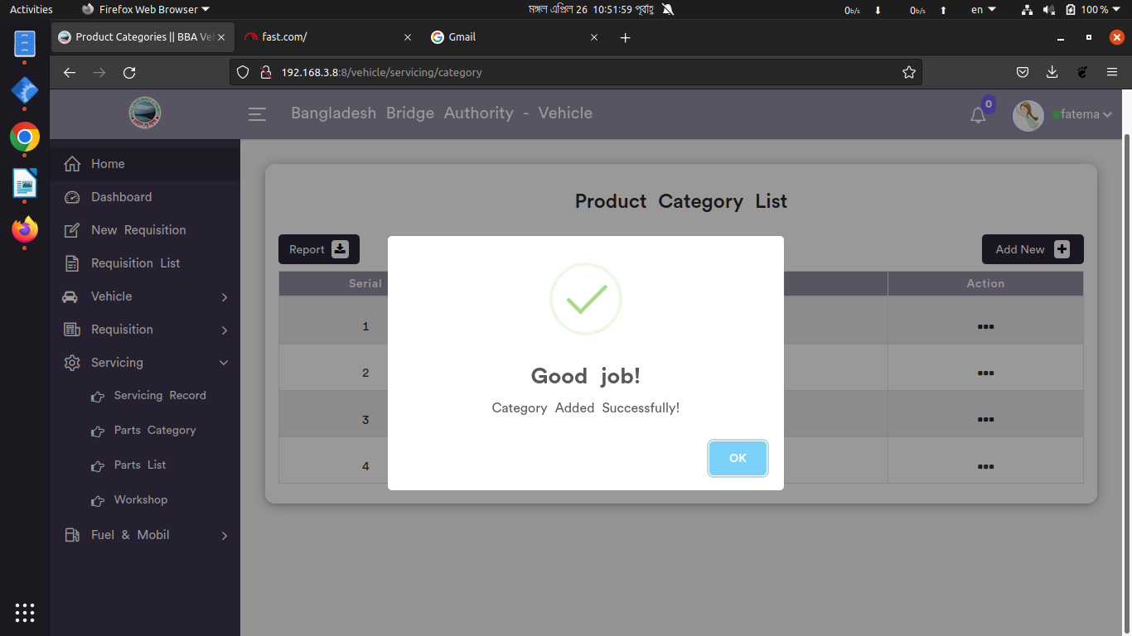

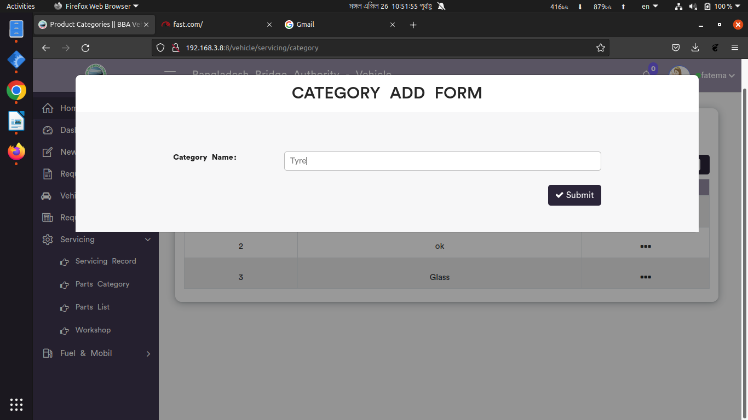

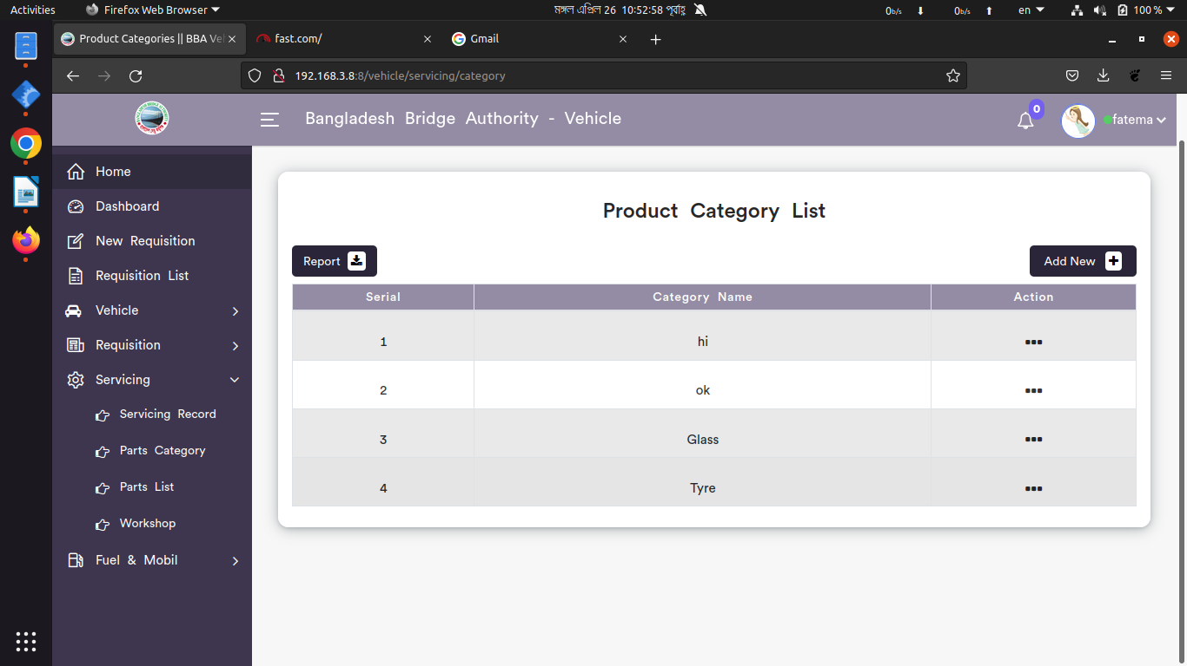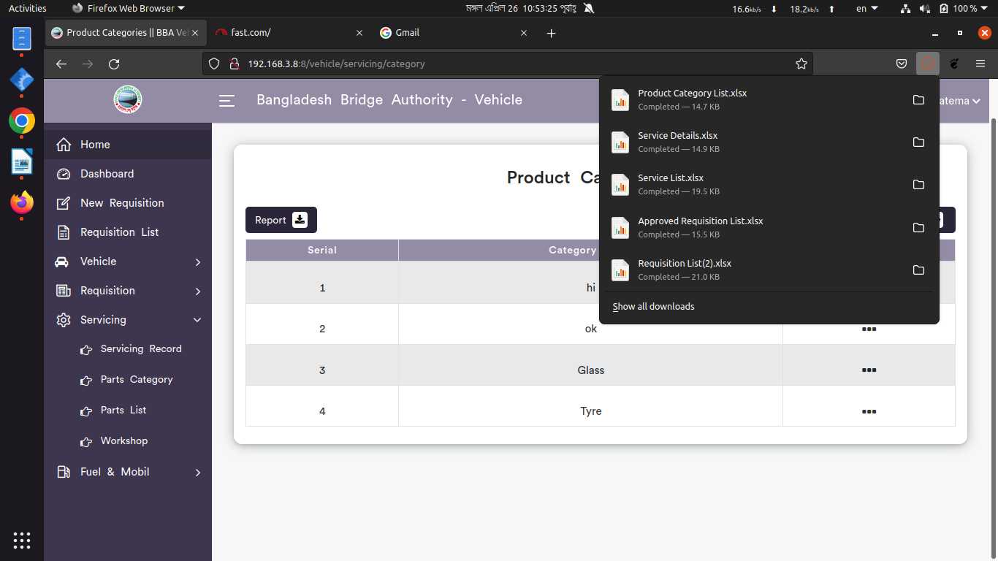

*Positive test case*

|  |  |  |  |  |  |
| --- | --- | --- | --- | --- | --- |
| Case ID | Title | Description | Expected Result | Actual Result | Pass/Fail |
| 1 | Add new | 1. Enter vehicle product category name  2. Click submit | Data saved successfully | No error while saving | P |
| 2 | Product Category List | Show all the vehicle Product category information | All information are displayed | No information is missing | P |
| 3 | Update | Update the existing information | Updated database | No error while updating | P |
| 4 | Report | Generated in Xcell format | Generated | saved | P |

*Negative Test Case*

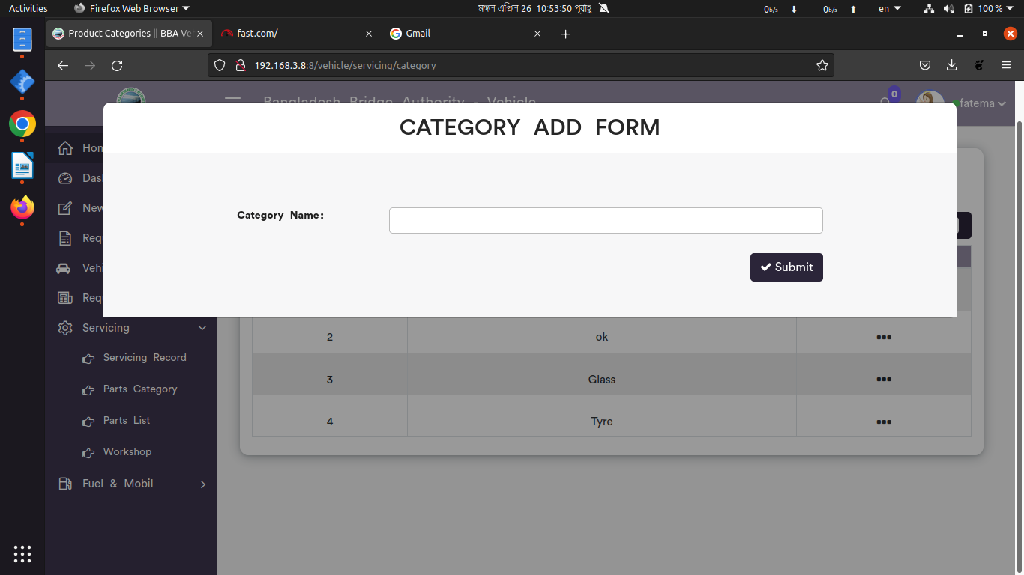

|  |  |  |  |  |  |
| --- | --- | --- | --- | --- | --- |
| Case ID | Title | Description | Expected Result | Actual Result | Pass/Fail |
| 1 | Add new | 1. Form should fill up  2. Submit button should perfectly work | Data checked | No error | P |
| 2 | Product Category List | No information is missing | No missing information | No error occurred while displaying | P |
| 3 | Update | Update the existing information in the list | Updated existing information | Perfectly executed | P |
| 4 | Report | Xcell file can be downloaded | Generated report | No error while saving the file | P |

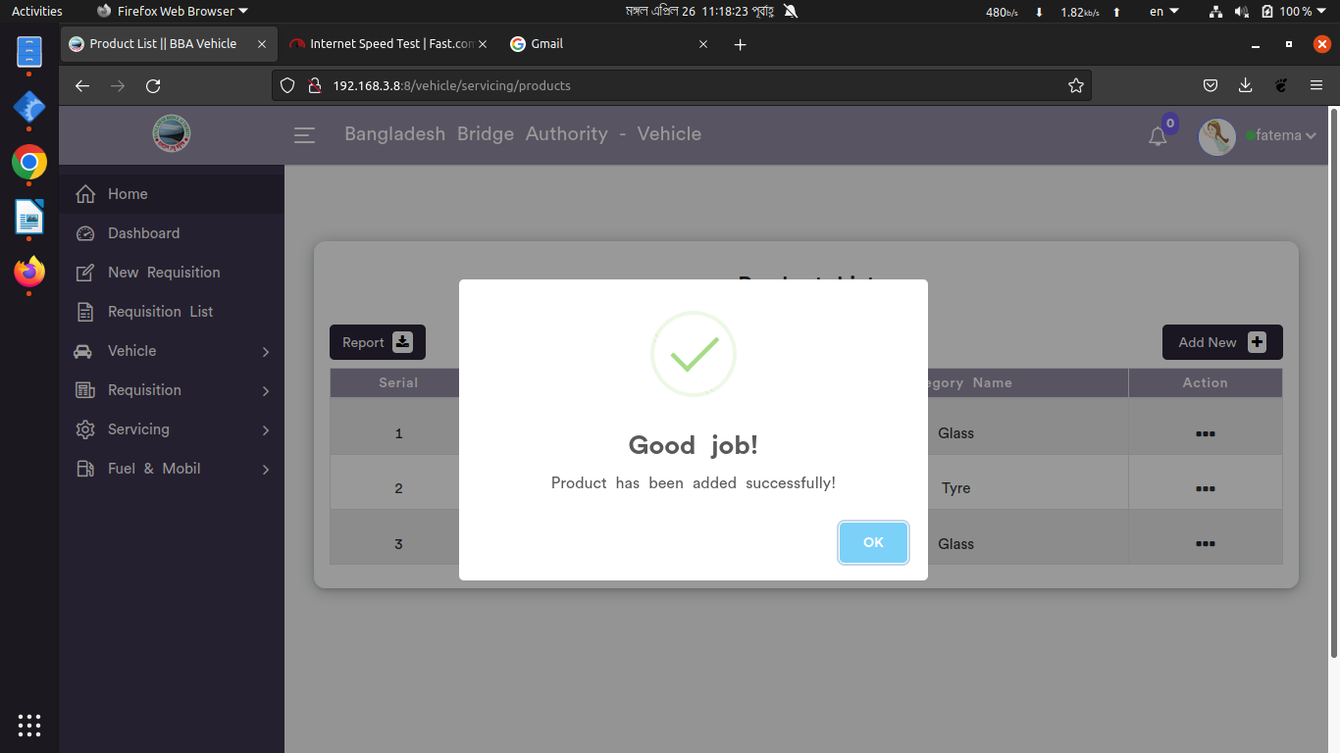3. Parts List

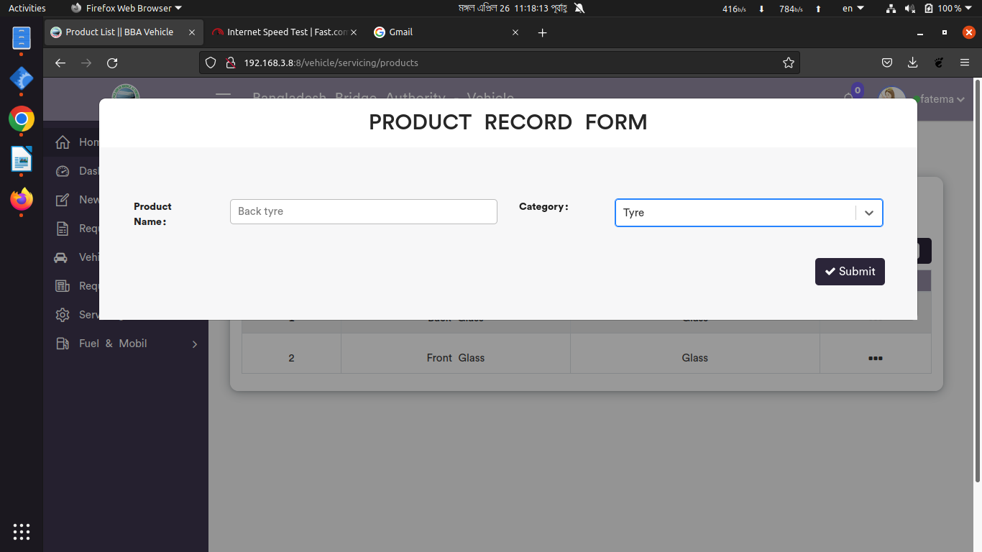

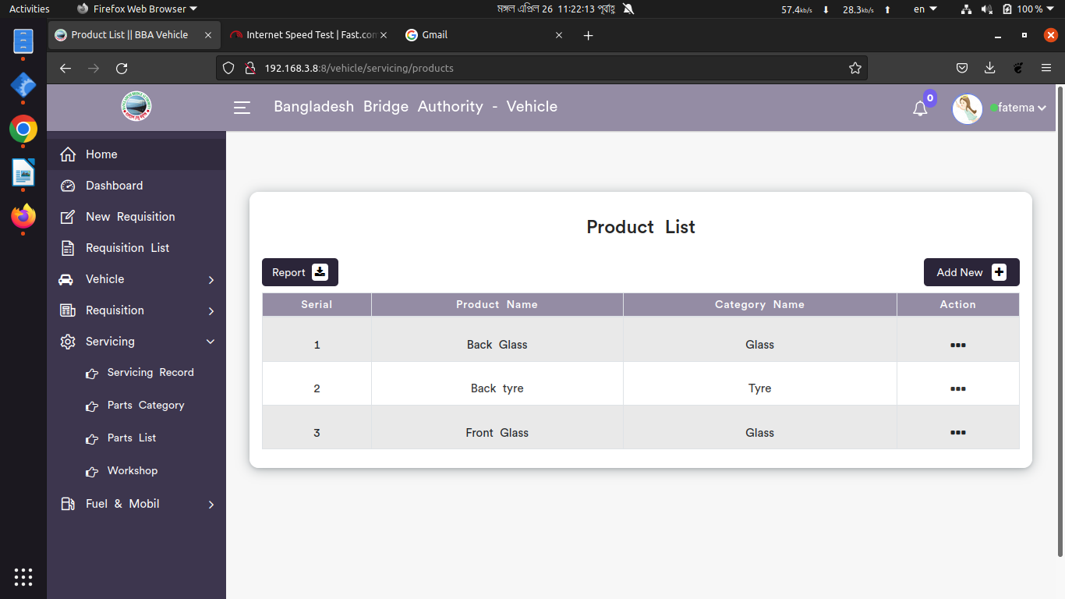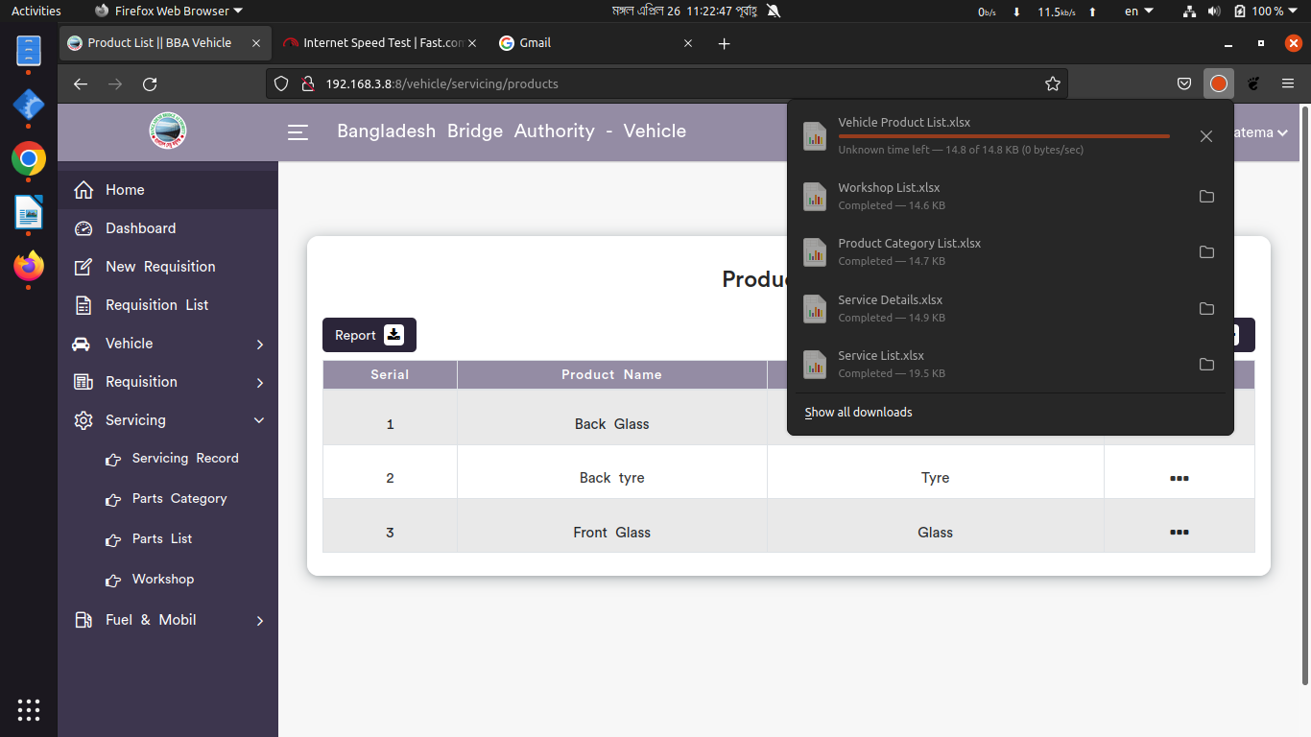

*Positive test case*

|  |  |  |  |  |  |
| --- | --- | --- | --- | --- | --- |
| Case ID | Title | Description | Expected Result | Actual Result | Pass/Fail |
| 1 | Add new | 1. Enter vehicle product category name  2. Click submit | Data saved successfully | No error while saving | P |
| 2 | Product List | Show all the vehicle Product category information | All information are displayed | No information is missing | P |
| 3 | Update | Update the existing information | Updated database | No error while updating | P |
| 4 | Report | Generated in Xcell format | Generated | saved | P |

*Negative Test Case*

|  |  |  |  |  |  |
| --- | --- | --- | --- | --- | --- |
| Case ID | Title | Description | Expected Result | Actual Result | Pass/Fail |
| 1 | Add new | 1. Form should fill up  2. Submit button should perfectly work | Data checked | No error | P |
| 2 | Product List | No information is missing | No missing information | No error occurred while displaying | P |
| 3 | Update | Update the existing information in the list | Updated existing information | Perfectly executed | P |
| 4 | Report | Xcell file can be downloaded | Generated report | No error while saving the file | P |

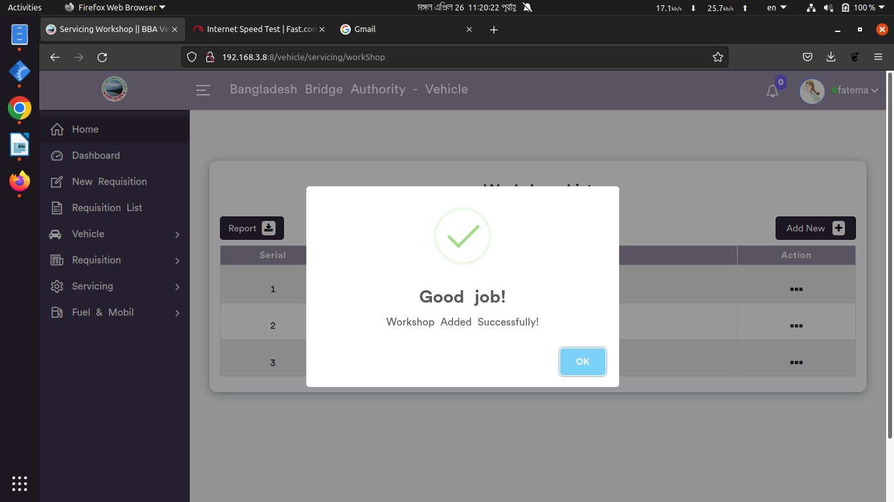3. Workshop

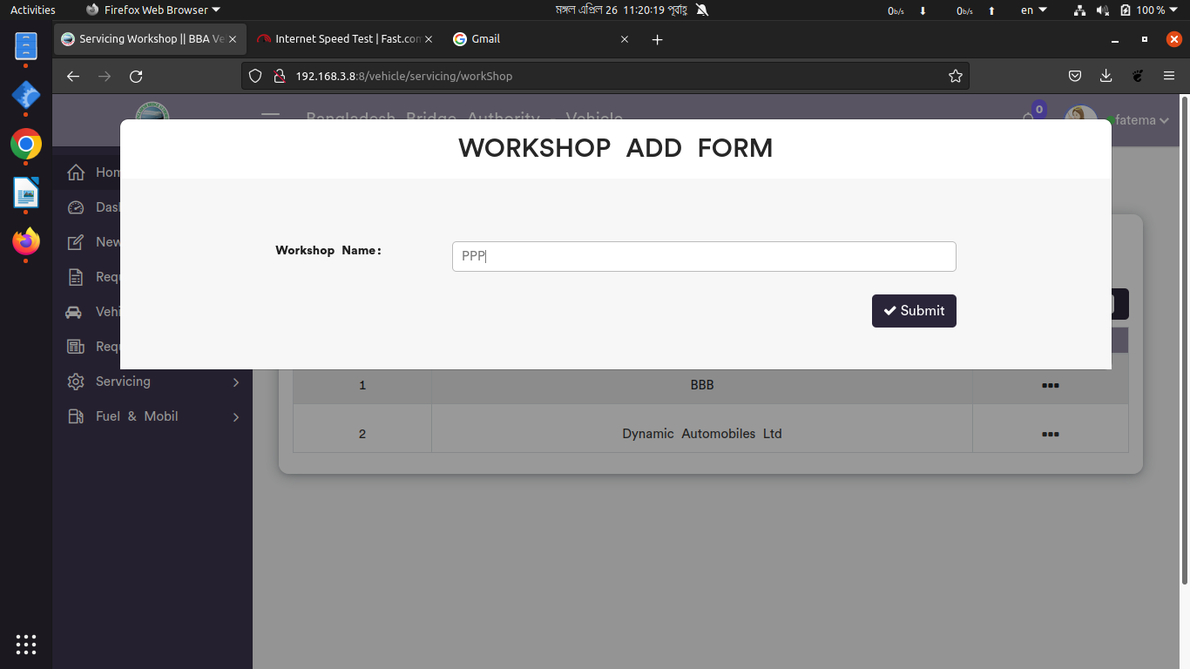

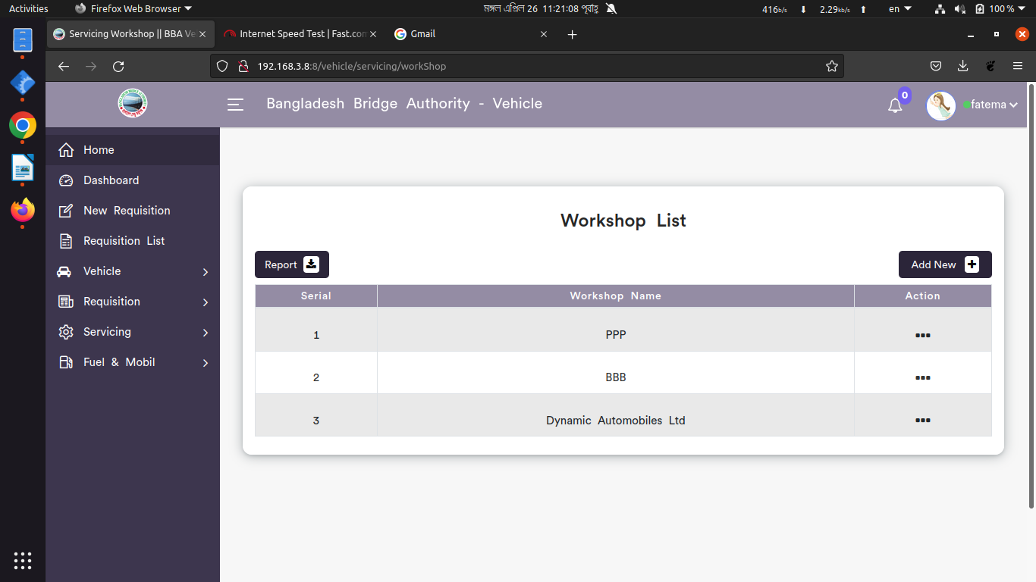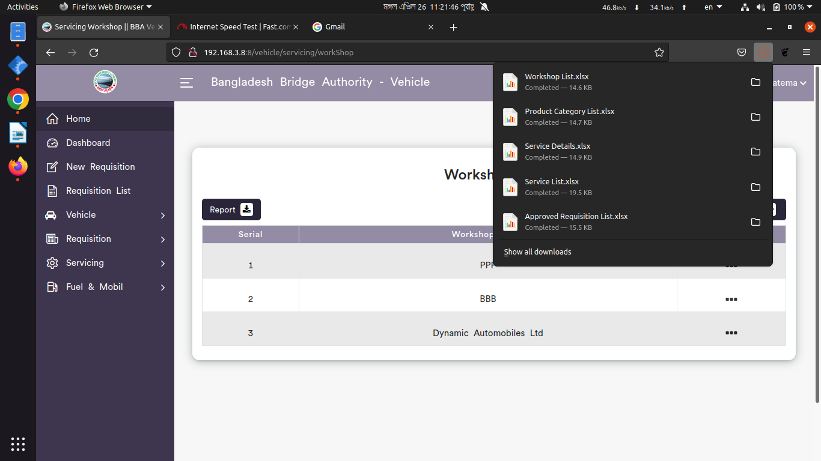

*Positive test case*

|  |  |  |  |  |  |
| --- | --- | --- | --- | --- | --- |
| Case ID | Title | Description | Expected Result | Actual Result | Pass/Fail |
| 1 | Add new | 1. Enter vehicle workshop name  2. Click submit | Data saved successfully | No error while saving | P |
| 2 | Workshop List | Show all the vehicle workshop information | All information are displayed | No information is missing | P |
| 3 | Update | Update the existing information | Updated database | No error while updating | P |
| 4 | Report | Generated in Xcell format | Generated | saved | P |

*Negative Test Case*

|  |  |  |  |  |  |
| --- | --- | --- | --- | --- | --- |
| Case ID | Title | Description | Expected Result | Actual Result | Pass/Fail |
| 1 | Add new | 1. Form should fill up  2. Submit button should perfectly work | Data checked | No error | P |
| 2 | Workshop List | No information is missing | No missing information | No error occurred while displaying | P |
| 3 | Update | Update the existing information in the list | Updated existing information | Perfectly executed | P |
| 4 | Report | Xcell file can be downloaded | Generated report | No error while saving the file | P |

**Test Scenario 8: Fuel & Mobil**

1. Fuel Record

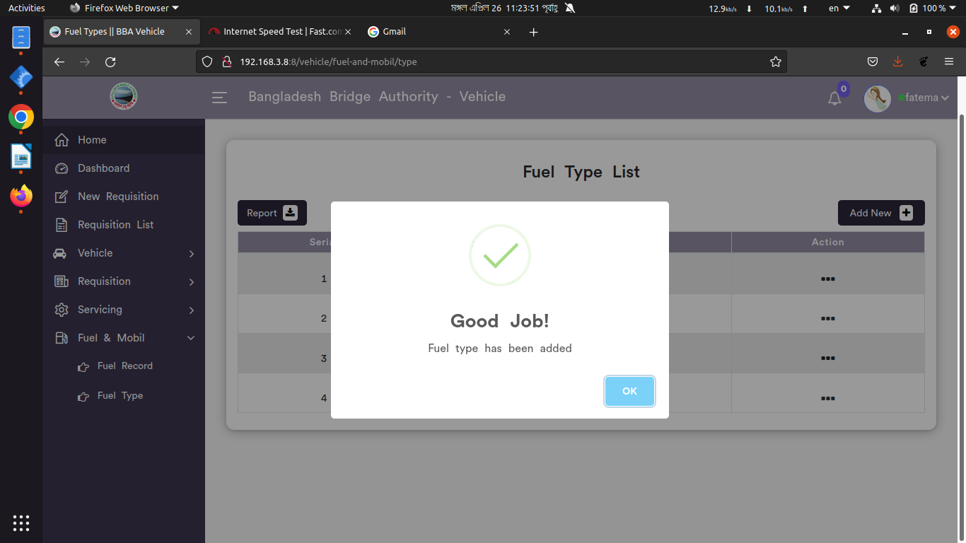

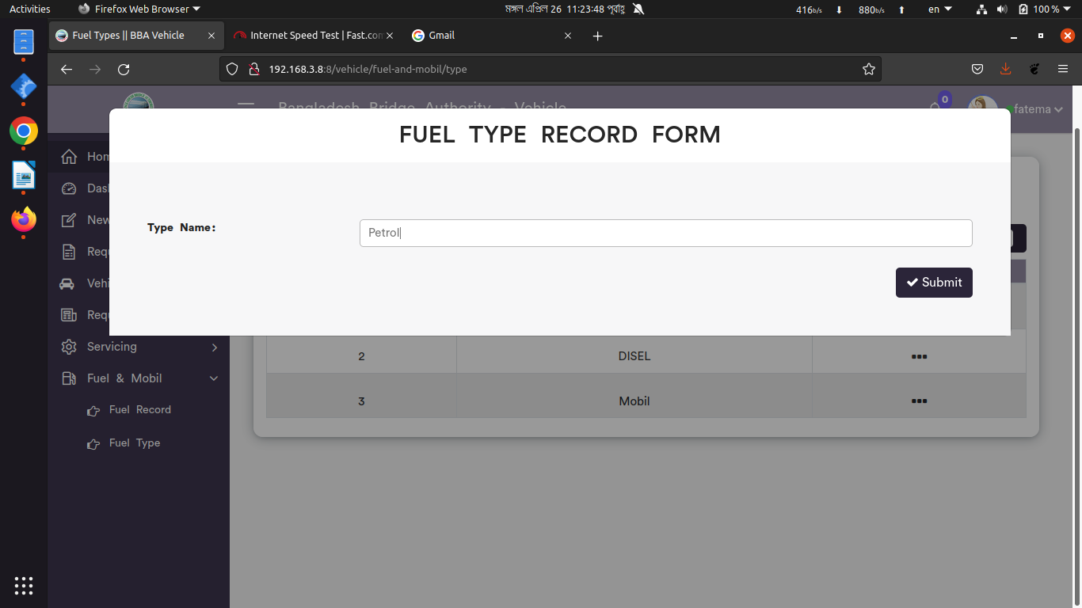

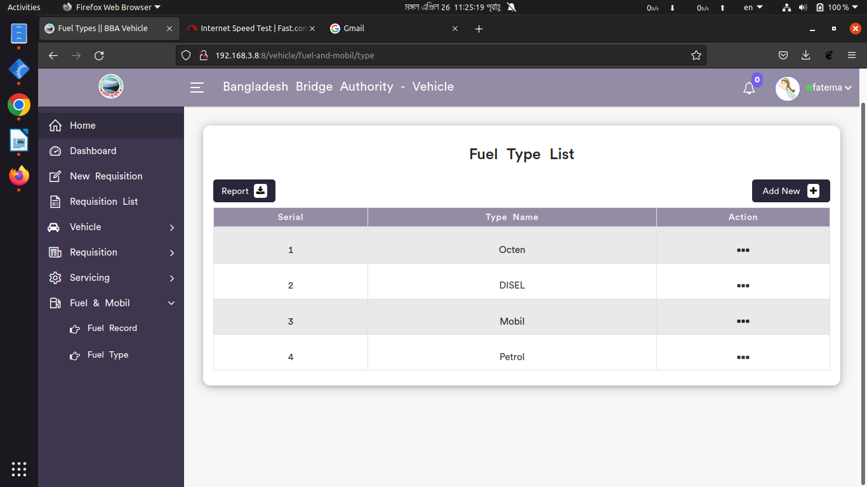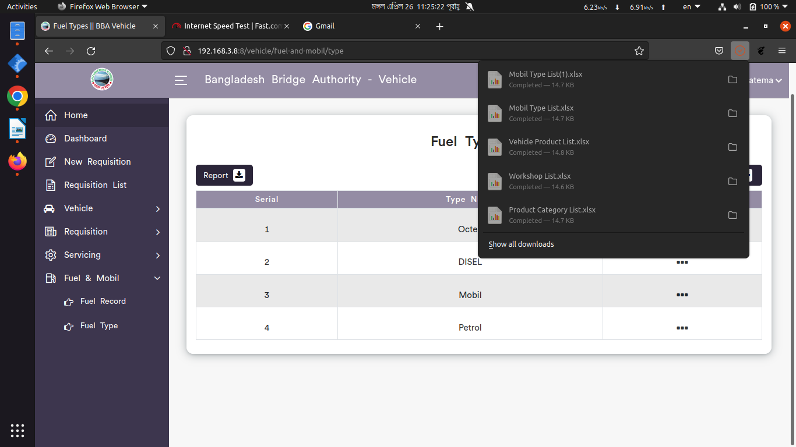

*Positive test case*

|  |  |  |  |  |  |
| --- | --- | --- | --- | --- | --- |
| Case ID | Title | Description | Expected Result | Actual Result | Pass/Fail |
| 1 | Add new | 1. Select vehicle reg no  2. Enter slip no  3. Select fuel type, date, requester  4. Enter quantity & cost  5. Click submit | Data saved successfully | No error while saving | P |
| 2 | Fuel Record List | Show all the vehicle fuel type information | All information are displayed | No information is missing | P |
| 3 | Update | Update the existing information | Updated database | No error while updating | P |
| 4 | Report | Generated in Xcell format | Generated | saved | P |

*Negative Test Case*

|  |  |  |  |  |  |
| --- | --- | --- | --- | --- | --- |
| Case ID | Title | Description | Expected Result | Actual Result | Pass/Fail |
| 1 | Add new | 1. Form should fill up  2. Data should be valid  2. Submit button should perfectly work | Data checked | No error | P |
| 2 | Fuel Record List | No information is missing | No missing information | No error occurred while displaying | P |
| 3 | Update | Update the existing information in the list | Updated existing information | Perfectly executed | P |
| 4 | Report | Xcell file can be downloaded | Generated report | No error while saving the file | P |

2. Fuel Type

*Positive test case*

|  |  |  |  |  |  |
| --- | --- | --- | --- | --- | --- |
| Case ID | Title | Description | Expected Result | Actual Result | Pass/Fail |
| 1 | Add new | 1. Enter vehicle fuel type  2. Click submit | Data saved successfully | No error while saving | P |
| 2 | Fuel Type List | Show all the vehicle fuel type information | All information are displayed | No information is missing | P |
| 3 | Update | Update the existing information | Updated database | No error while updating | P |
| 4 | Report | Generated in Xcell format | Generated | saved | P |

*Negative Test Case*

|  |  |  |  |  |  |
| --- | --- | --- | --- | --- | --- |
| Case ID | Title | Description | Expected Result | Actual Result | Pass/Fail |
| 1 | Add new | 1. Form should fill up  2. Submit button should perfectly work | Data checked | No error | P |
| 2 | Fuel Type List | No information is missing | No missing information | No error occurred while displaying | P |
| 3 | Update | Update the existing information in the list | Updated existing information | Perfectly executed | P |
| 4 | Report | Xcell file can be downloaded | Generated report | No error while saving the file | P |